A whole school approach to securing times-tables
Long Term Plan
 | Autumn |  | Spring |  | Summer
 | Term 1 | Term 2 | Term 3 | Term 4 | Term 5 | Term 6
EYFS | Pre-requisites 1 to 3  1. Unitizing  2. Bringing together more than one unit  3. Equal and un-equal groups
Year 1 | Pre-requisites 1 to 4  1. Unitizing  2. Bringing together more than one unit  3. Equal and un-equal groups  4. Understanding the early relationship between + and x  Experience of counting in 2’s, 5’s and 10’s.
Year 2 | 1x | (1x) 2x | 5x | (5x) 10x | 0x (and revision) | Revise 2s, 5s and 10s and 0s
Year 3 | (2x) 4x | (4x) 8x | 3x | (3x) 6x | (6x) 12x | Revise 0s, 1s, 2s, 3s, 4s, 5s, 6s, 8s, 10s and 12s
Year 4 | 9x | 7s | 11x | Squares | Revise all times tables | Multiplication Check
Year 5 | Assess gap analysis (TT Rockstar grids) | Revision of times tables needed (Identified from term 1 assessment) | Revision of times tables needed (Identified from term 1 assessment) | Revision of times tables needed (Identified from term 1 assessment) | In school gap analysis | Revision of times tables needed (Identified from term 5 assessment)
Year 6 | Assess gap analysis (TT Rockstar grids) | Revision of times tables needed (Identified from term 1 assessment) | Revision of times tables needed (Identified from term 1 assessment) | Revision of times tables needed (Identified from term 1 assessment) | In school gap analysis | Revision of times tables needed (Identified from term 5 assessment)
* The times table in brackets indicates the times table that should be used and referred to when introducing the new times table.
In Your Classroom

Each half term, your classroom will display a focus on one specific times-table. This is a working wall and should showcase the different ways the times-table has been explored. As you progress through the different stages outlined in this document, your wall display will development.
Key areas you want to include in your display:
- Where does the times-table exist in real life?
- Egg cartons that show the 6 times table
- Hands and feet that show both the 2 and 5 times-table
- The different representations of the times-table being explored
- Photographs (concrete)
- Drawings (pictorial)
- Fluency (abstract)
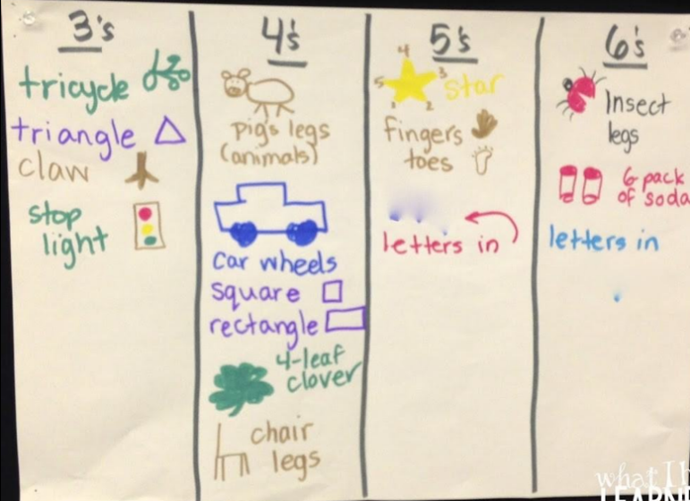

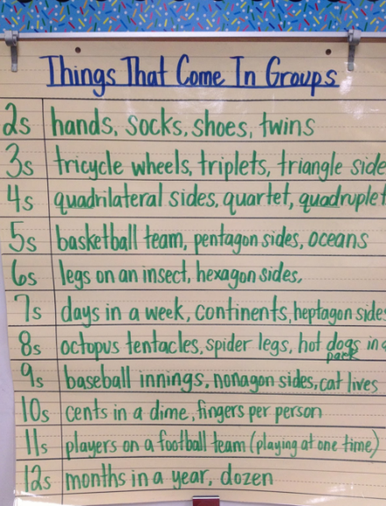
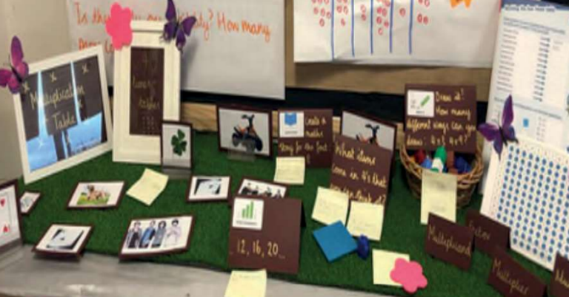
Exploring A New Times-Table

Whenever we introduce a new times table, it is always a good opportunity to explore our understanding of that number. This can be looking at real life connections (links to wall display), arrays to represent that multiplication and explicit links to other times table we may have already learnt (bracketed times-tables on the long-term plan).
Having this opportunity to create the times-table using a range of resources allows for the children to engage in maths talk.
What do they notice about the multiples in this times-table?
Even / odd All end in… Digits total…
Is there a pattern we can see?
Do they link to a times table we already know?
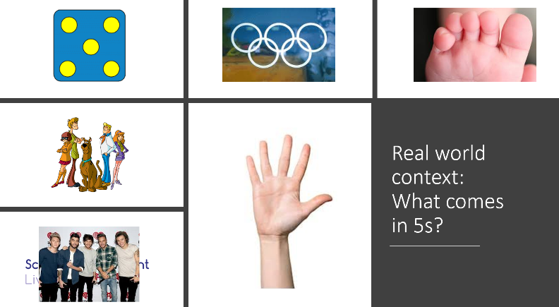
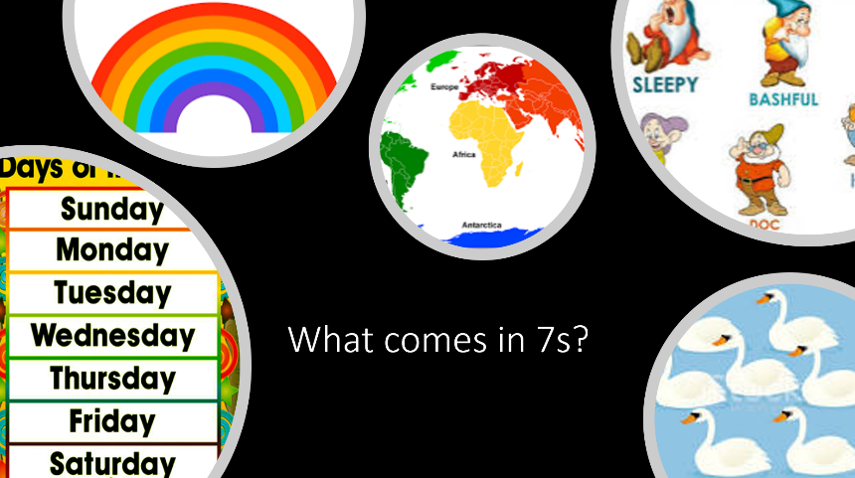

Vocabulary: It is important that as a school we are using the same language when learning our times tables. It is good to make the children aware of vocabulary associated to multiplication but when we are reciting the times tables, it is important to represent and say the same vocabulary. For example, when we are doing the 4 times tables, the language used would be ‘One times 4 is’ represented by 1 x 4 =, rather than 4 x 1. This means the times-table you are exploring will always be the second number in the multiplication sentence.

Using the CPA approach
Learning times-tables can often become a focus on rote learning without understanding. Learning solely based on chanting and reciting. Children can often develop effective recall but this knowledge has no further application. Links are not made to near multiples, mega/mini facts and connections to learning in other areas of maths. There is a place for this style of learning for developing arithmetic and fluency, but we must offer more substance to ensure children are given the opportunity to make connections.
In the same way we follow a CPA (concrete, pictorial and abstract) approach in our mastery lessons, it is important to apply this same mentality to our times-tables sessions.
Concrete
Give the children the opportunity to represent the times-table being explored in different ways. This should include using a variety of resources – cubes, numicon, counting beads, 100 squares, counters, base 10, ten frames, washing lines, images etc.
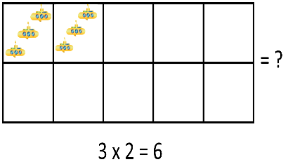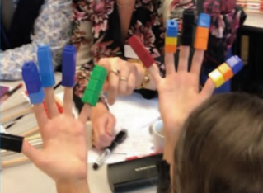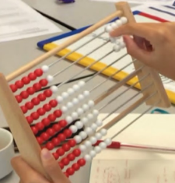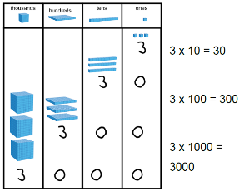
The counting stick should become a commonly utilised resource throughout the times table sessions. A whole school approach will be through starting with a blank stick. As a class, you will complete the stick in a set sequence, as the answer is identified, the value is added to the counted stick.
0 x _ =
1 x _ =
Double (2 x _ = )
10 x _ =
One less (9 x _ =)
5 x _ = (half of 10 x _ = / middle point)
The key (3 x _ =)
Double the key (6 x _ = )
4 x _ =
8 x _ = (double 4 x _ =)
7 x _ = (one less than 8 lots or one more than 6 lots)
Chant the counting stick
Repeatedly count / remove multiples and repeat. Leaving the more challenging multiples until the end.
* The key is a hook for the children to grasp the 3rd times table / double the key = 6 times tables
Extension: Once the counting stick is completed, the children chant the times tables forwards, backwards and specific times tables. As the children become more confident, multiples can be removed until eventually the children are chanting the whole times table without a value on the counting stick. Link this to a variety of games (speed challenge, ping-pong, say one more than I call)
Extension 2: Create the times table using mini / mega facts. (See ‘Going Deeper’ section).
Pictorial
Children use their knowledge of the concrete phase to represent the times table using arrays, drawings and number lines.
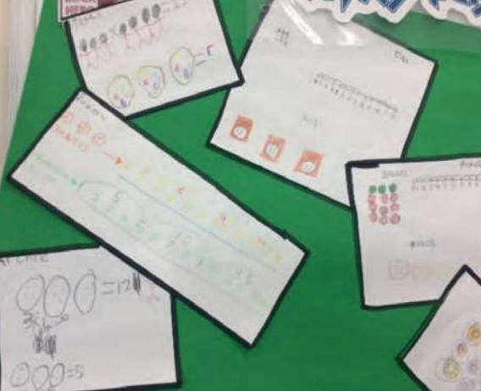 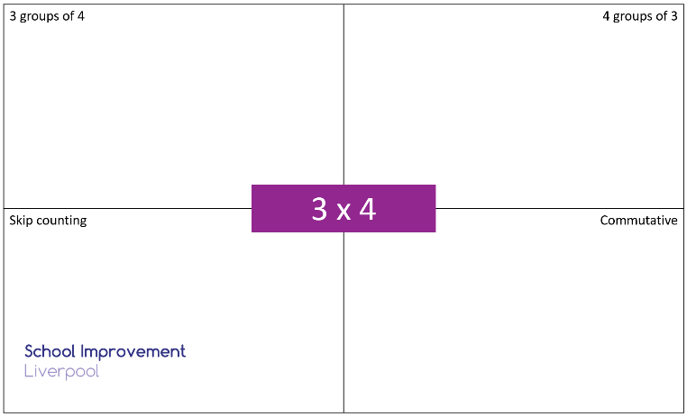

Abstract
Abstract is using their knowledge from the abstract and pictorial phase to build fluency and recall of the times tables. This can be through chanting, exploring songs or creating actions / raps. The more frequent these activities are, the more secure the children’s ability to recall those times tables become. Ideally, doing this 3 to 5 times a week for 10 minutes helps consolidate the learning from the sessions.

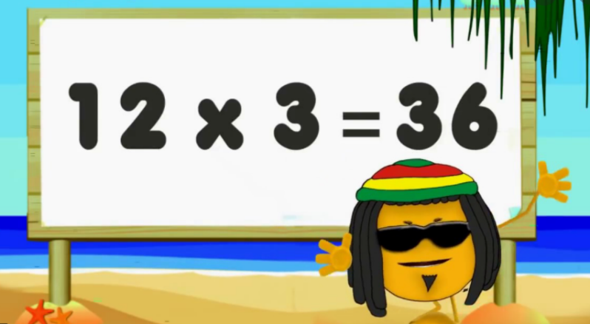
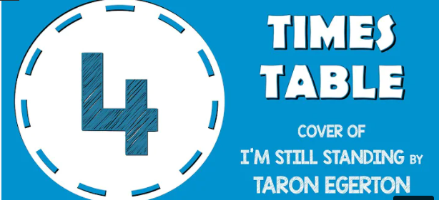

Going Deeper

Like with any subject, we will have children who do not know their times tables and those that are fluent. In the same way we would not move onto content in other year groups in our maths lessons, we need to have the same mindset with learning our times tables. It should be about exploring the times table in more detail and going deeper. Going deeper is all about making connections with the what the children already know. These explicit links of pattern spotting supports children in developing a more secure understanding.
Commutative Law
This is the understanding that a times table can be reversed and still give the same answer. If the children are secure with their three times table, they have also learnt part of the other times tables as 4 x 3 = 12 gives the same answer as 3 x 4. This should be explored with arrays and times table grids.
Inverse
Explore the relationship between multiplication and division. Understanding that 12 can be divided up into 3 groups 4 or 4 groups of 3 makes a connection between the families.
Mini and Mega Facts
Once the children know a times table, they can then identify the associated mini and mega facts. A mini fact is when we use our 3 times table to identify the 0.3 times table. A mega fact is when we use the 3 times table to help identify 30 or 300 times table.
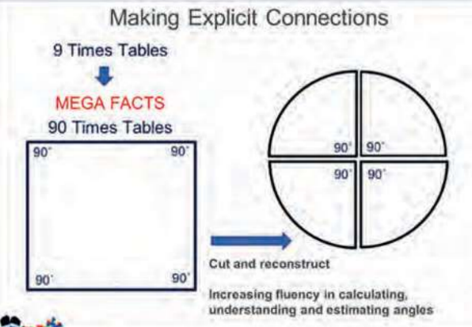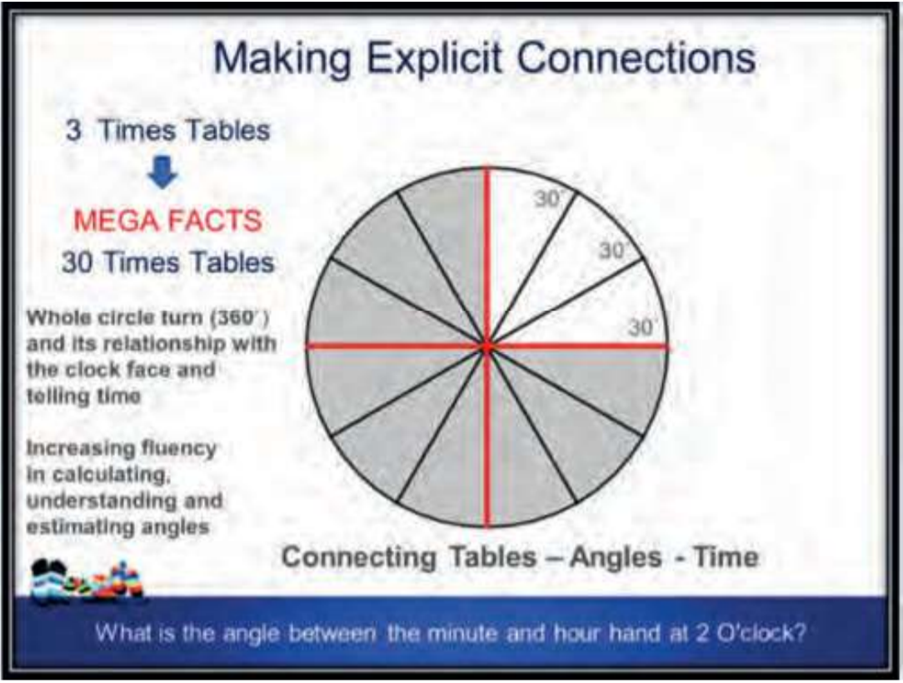

Distributive Law
With the support of an array, it is possible to show the children how a times table can be partitioned. This skill can support children in solving more complex calculations and make connections.
E.g. 12 x 4 = (10 x 4) + (2 x 4)
6 x 5 + 4 x 5 = 5 x 5 + 5 x 5 = 10 x 5
2 x (4 x 3) = 24 or (2 x 4) x 3 = 24
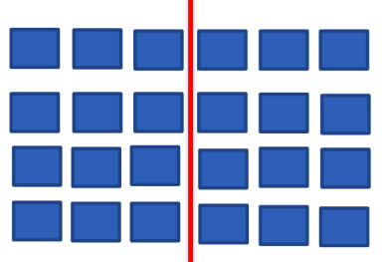 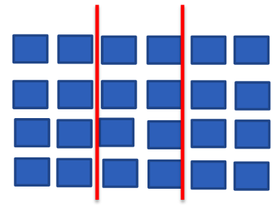
E.g.2 9 x 4 = (10 x 4) – 4 or 8 x 4 = (10 x 4) – 8 or 11 x 4 = (10 x 4) + 4

Doubling and Halving
Within the teaching of the times tables, you will be making explicit links to double and halving. This might be through knowing what 10 lots of a times table would be and halving this to find 5 lots or it could be using your knowledge of the 3 times table to work out the 6 times table.
- If we know 2 lots, we can work out 4 lots.
- If we know 4 lots, we can work out 8 lots.
- If we know 10 lots, we can work out 5 lots.
- If we know 3 lots, we know 6 and 9 lots etc

Lesson Overview
Whole School Approach
Our whole school approach comprises of 4 pre-requisites. The pre-requisites (outlined on EYFS and year 1’s long term plan) allow pupils to explore the knowledge needed prior to securing their times tables. The NCETM professional material are an excellent resource for exploring these.
Timetable – Summer term
These sessions will be delivered on a weekly basis, replacing the slot currently assigned to assertive mentoring. The children will complete a 4-week cycle of focussing on a specific times table. On the fifth week, the children will do an assertive mentoring session. This assertive mentoring sheet must be stuck into maths books and used as a ‘next steps’ guide on areas of focus to ensure the children can make progress when they do their next assertive mentoring session in 5 weeks.
Over the summer term, you will look to cover 2 sets of times tables. Using the long term plan, select the most appropriate starting place for your class. TT Rockstar heat maps are an effective tool in identifying your starting point.
Lesson focus
Within a 4-week cycle, the aim of these sessions is to consolidate the children’s times tables skills through engaging and practical sessions. Each lesson should have a specific focus and meet one of the components. Over a series of lessons, all components will have been delivered.
Component 1 – Regular retrieval practice (10 minutes up to 3 times a week) with conceptual support.
Component 2 – Building and representing the times table.
Component 3 – Making clear conceptual links to the real world.
Component 4 – High quality activities / games linked to the times table being explored.
*Quizzes can be used but should be informal, low stakes and not the main activity.
Component 5 – Regular exploration of the CPA model
Emphasis on exposure to arrays (with links to number blocks)
Component 6 – Explore patterns within the times tables – repeating digits, reversing digits, addition of digits, divisibility and how the times table relates to other times tables.
Component 7 – Exploration of the times table through variation – links to other areas of maths (measure / data handling / geometry) and the objectives outlined in the ‘Going deeper’ section.
Component 8 – Consolidate times tables through application / problem solving.
Evidence
These sessions should be practical and engaging, therefore it is not essential to have work completed in books. Alternatively, evidence for these sessions could be through pictures showcasing the individual learning from the lesson.

Suggested activities and games
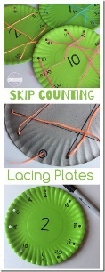
Skip Counting Lacing Plates
Skip Counting Lacing Plates Activity (123homeschool4me.com)
This activity provides both times table recall and the ability to practice fine motor skills as the children thread a lace through the plate in the sequence of the times table. Resources:
- Paper plate
- Whole punch
- Sharpe
- Lace

Picture Chop
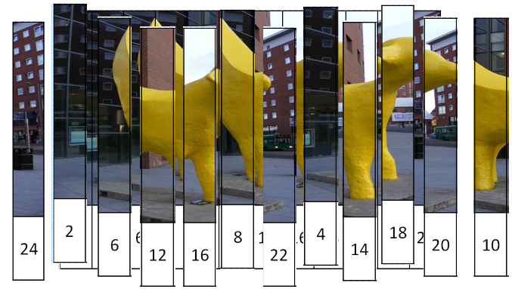 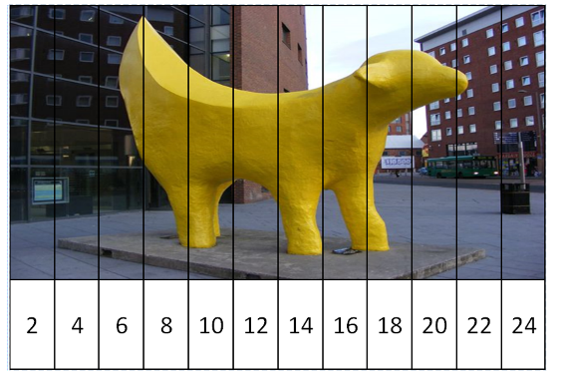
Take an image (could be cross-curricular linked) with the multiples across the bottom, the image is cut into strips and the children complete a time challenge to rearrange the image. This could be done as an independent task, a paired task (alternate turns) or as a whole class.
Ext: Muddle up the picture, ask a partner to close their eyes, remove a strip, see if they can identify the missing strip (timer could be added to add a competitive element).
Coins in a tin
Children listen to coins being dropped into a tin, one coin = 1 x _ =. The children can then write their number on a whiteboard until you ask for them to show. By avoiding it being fastest hand, it becomes a more inclusive activity as it isn’t solely based on speed. The aim of the game might be to collect as many right answers as possible in 10 turns. This can be adapted into a paired game, allowing the person dropping the coins in the tin to use a times table card to build confidence.
Array Hunt
Have children search for real life arrays, this can be in the classroom, around the school or on the playground.
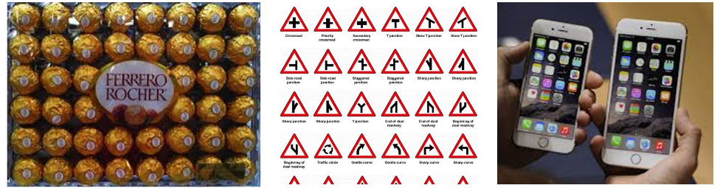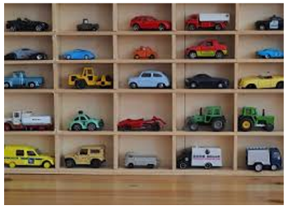

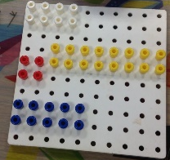
Arrays on peg boards
Children create certain arrays on peg boards to see both the commutative law and the distributive law. If an array is made up of blue and yellow pegs, what array does the blue show? What array does the yellow show? What array does it show combined? Also, the children will see that 4 x 3 = 3 x 4.

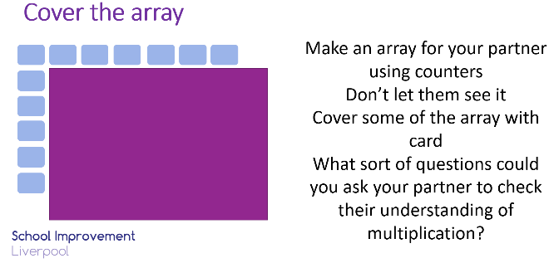
Cover the array
If children draw / make an array and cover part of it with a piece of paper, what can their partner tell them about their array? What questions could they ask? As the activity progresses, the children can show more and more of the array and see if they can answer their previously posed questions and can they get closer to identifying the multiplication being represented.
Target array
Give the children a target number and they must try and represent that number using an array. This provides the children to apply their factor knowledge in identifying 2 numbers that multiply to make 20. This can be left open ended:
Bronze – find an answer
Silver– find more than 1 answer,
Gold – find all of the answer.
Array Capture
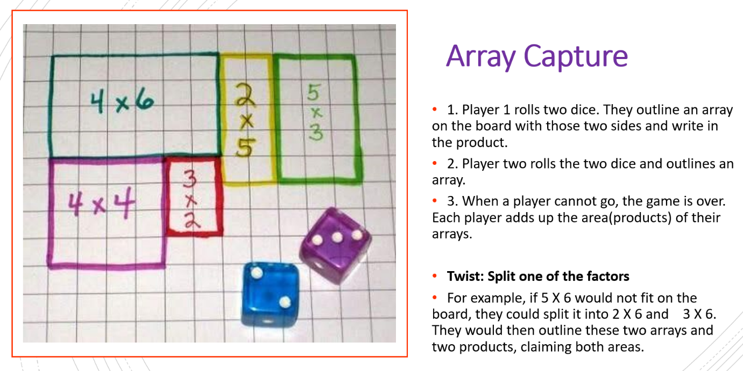
* If you want the children to only focus on one multiple, they could add the total of 2 dice or just play with a single dice and multiply it by the times tables being focussed on.
Coded tables
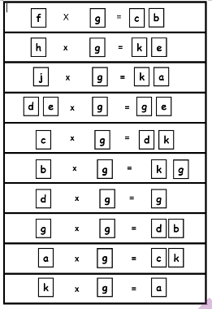
Each coded table represents one of the times tables being explored. This activity is all about pattern spotting and reasoning.

Here the children try and work out what times table ‘g’ is.
- How many single digit answers?
- d x g = g so d must be 1 as it gave the same answer.
- de x g = ge telling us e = 0 because…

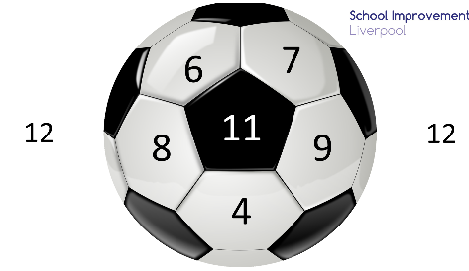
Drop the ball
2 or more players drop a dice onto a print out of the football, depending on where it lands you multiply the dice value by the football value. In each round, the person with the highest value takes the point, the first to 10 points win.
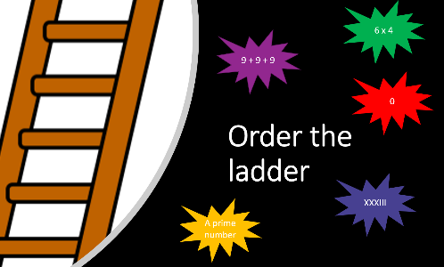
Order the ladder
Give the children a selection of calculations that they have to order from smallest to largest. This can include square numbers, commutative law and distributive law all linked to the times table you are exploring. It would also be possible to make links to the learning taking place in the maths lessons.

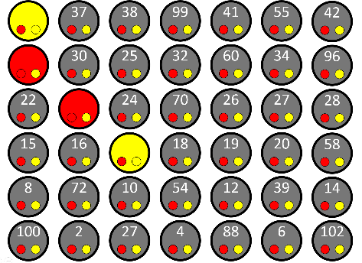
Interactive 4 in a row
This interactive board can be adapted to match the times tables you are focussing on. There are multiple ways that this game can be played but the aim is to achieve four in a row. The children / teams take it in turns to colour a number – this can be through rolling dice or being able to choose the times tables that makes that product. Once a team achieves four in a row, they have won.
Factor Times Table
The children are given a bingo card. You can either call a number / roll a dice / use number cards to select a value from 1 – 11. From there, the children can cover any multiple of that number (If you call 5, the children could cover 5, 10, 15, 20…60). Person to cover a line/full house is the winner.

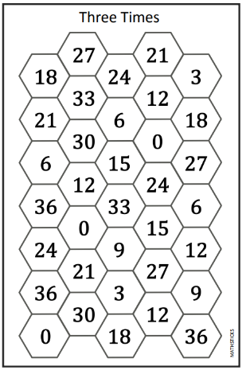
Times Table Pathway
The idea of the game is to create a path of counters that crosses the game board from left to right.
The counters and the dice are placed in the middle of the table, and each player keeps their game board in front of them. The players use the dice to generate a number by either adding or subtracting (see information box opposite). This number is then multiplied by the number of the board.
For example, on this Twelve Times board the player has rolled a 5 and 6 and chosen to add to create 11, this is multiplied by 12 and the number 132 covered.

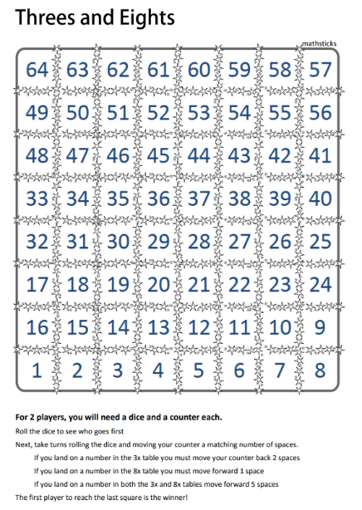
Multiples snakes and ladders
The game is very much like snakes and ladders, with the objective being to travel along the board from square 1 to the final square. The snakes and ladders however are replaced by the children's knowledge and their times tables, and their mathematical skills.
For example: on the Threes and Eights board players who land on a number in the 3x table must move their counter back 2 spaces. If they land on a number they recognise as being in the 8x table they can move forward 1 space. Should they land on a number which they know to be in both the 3x and 8x tables then they move forwards 5 spaces.

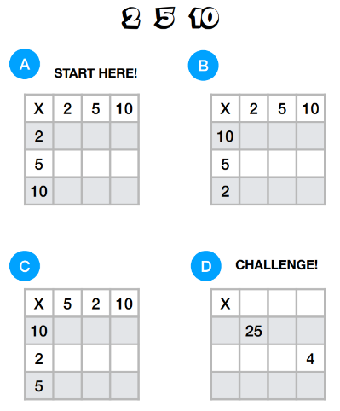
Building Tables Fluency (Andrew Jeffrey)
This short 5-minute activity is a good way to consolidate the link between specific times tables (e.g. 2, 5 and 10). The children complete the missing products in A, B and C and then use the commutative law to identify the values that would make that product. This task can be repeated throughout a week to consolidate the children’s understanding of those times tables. As the children become more confident, the grid sizes increase.

Games
A lot of these games relate to numerous times tables but could be easily adapted to focus on the times table you are exploring in class.

Top Trump Tables: UKS2 (Uses all times tables up to 12 x 12)
Monster Towers: 2 versions (2, 3, 4, 5, 10 and 11) or (5, 6, 7, 8, 9 and 12)
Rockstar Road: 2 versions (2, 3, 5 and 10 times tables) or (2 to 6 times tables needed)
Roll a Product – Need to know 1 to 6 times tables.
Roll calculate a colour –5 versions (x2, x5, x10) (x2, x4, x8) (x3 x6 x9) (x5 x7 x9 x11) (x6 x11 x12)
Four in a row – PDF is a UKS2 version but can be adapted easily to suit different times tables.

