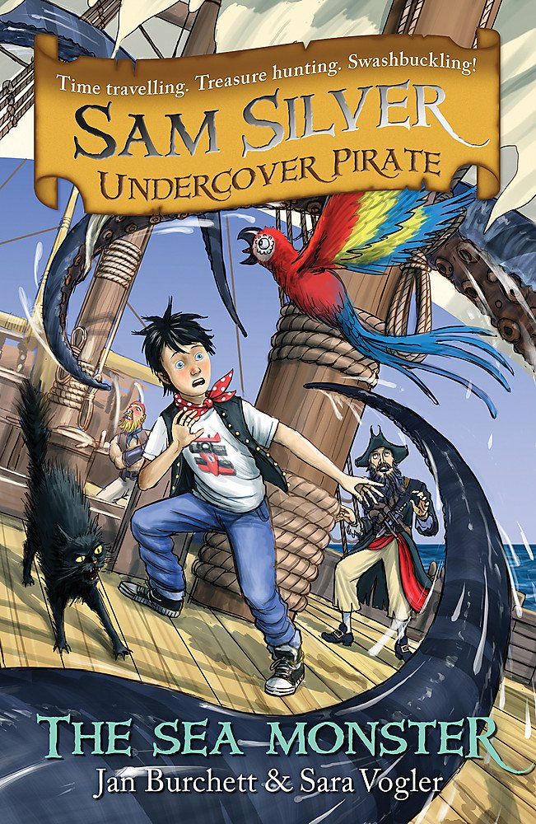
Using the stars to navigate the open sea action
Surviving in different habitats
Knowing the animals he will encounter in the ocean
How Does Sam Silver Use
Science at Sea?

