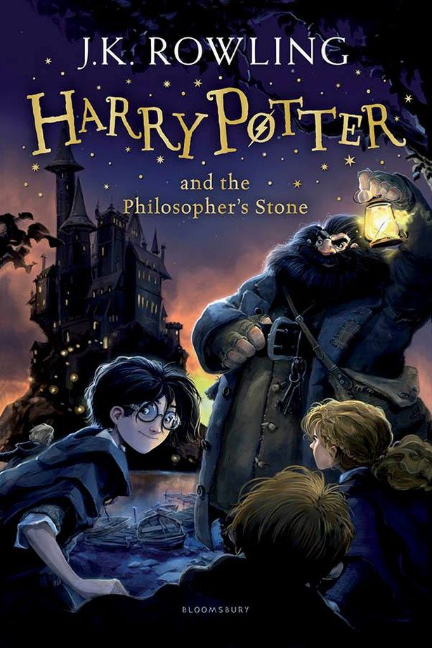
The habitats of mythical creatures
Rocks and fossils that contain magic
How to mix ingredients to create a potion
What Science Does Harry Potter Learn in Hogwarts?

