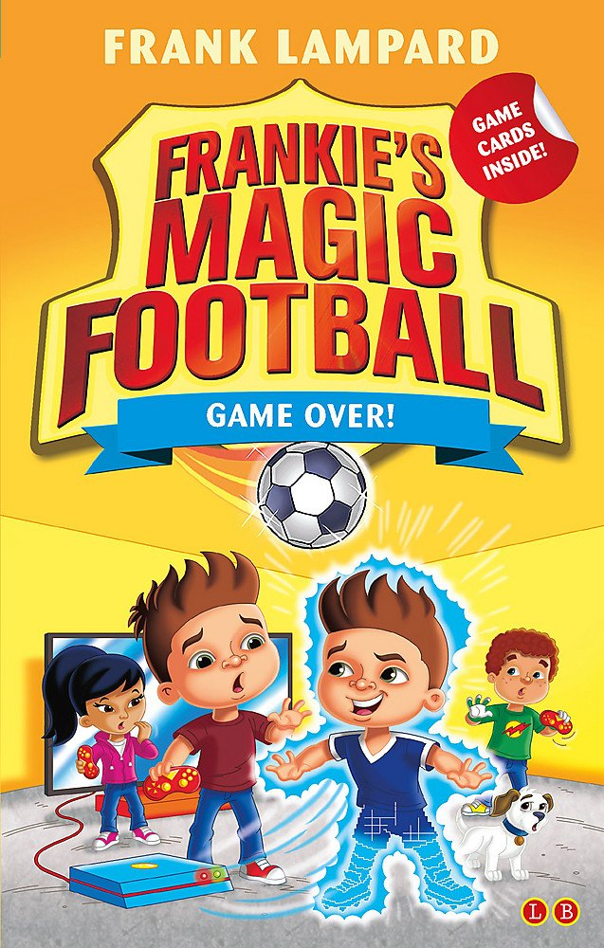
Keeping himself fit and healthy
Using the right force for every pass and shot
Using his senses on the football pitch
How Does Frankie Use Science to Be a Better Footballer?

