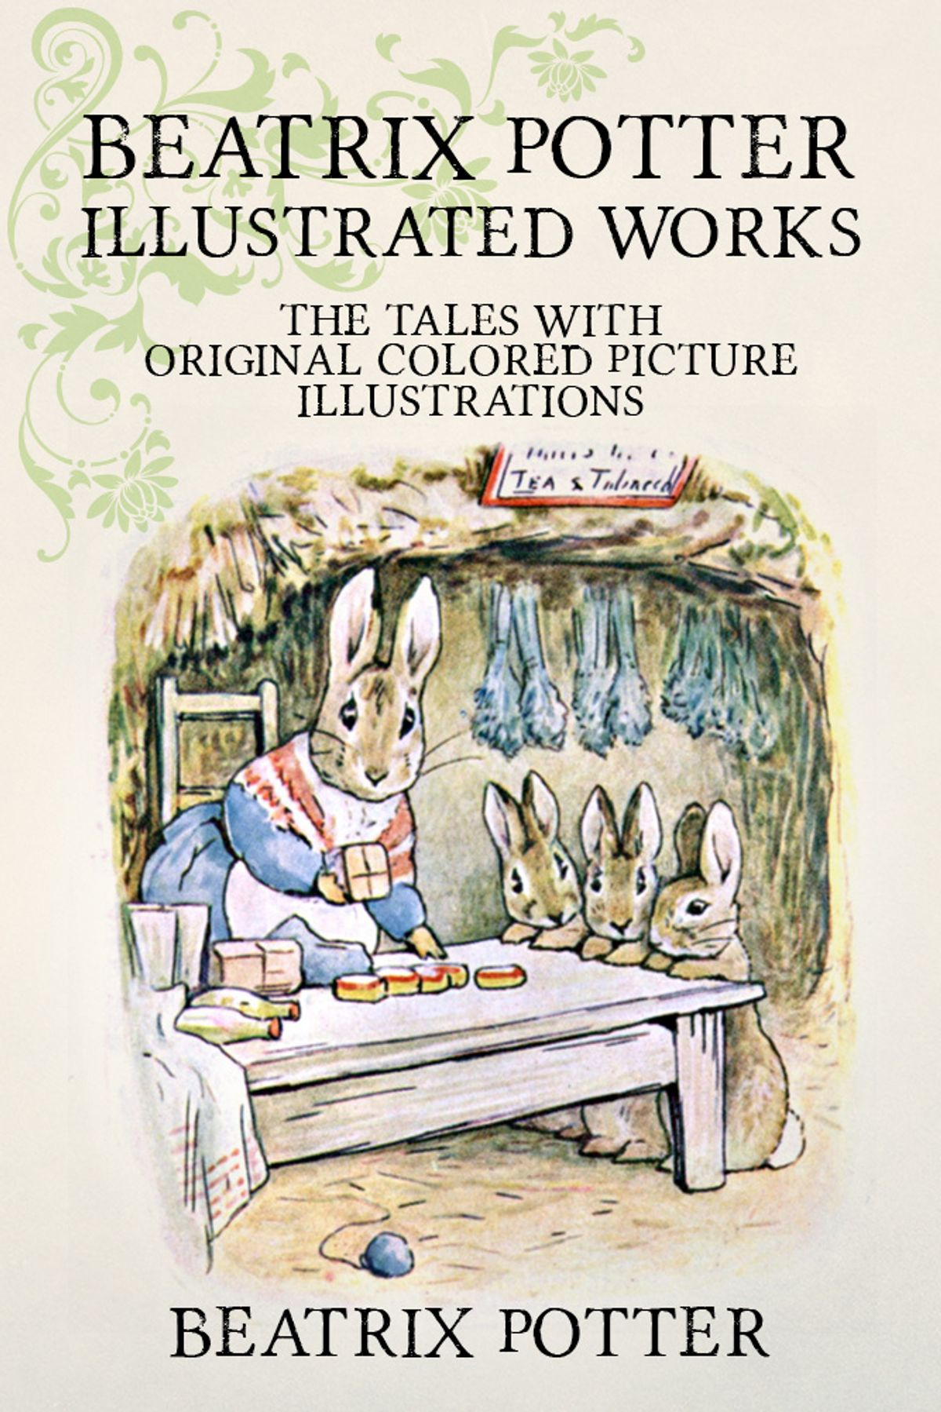
Habitats
Seasonal changes
Plants and flowers
Features of animals
What Science Surrounds Peter Rabbit in the Woods?

