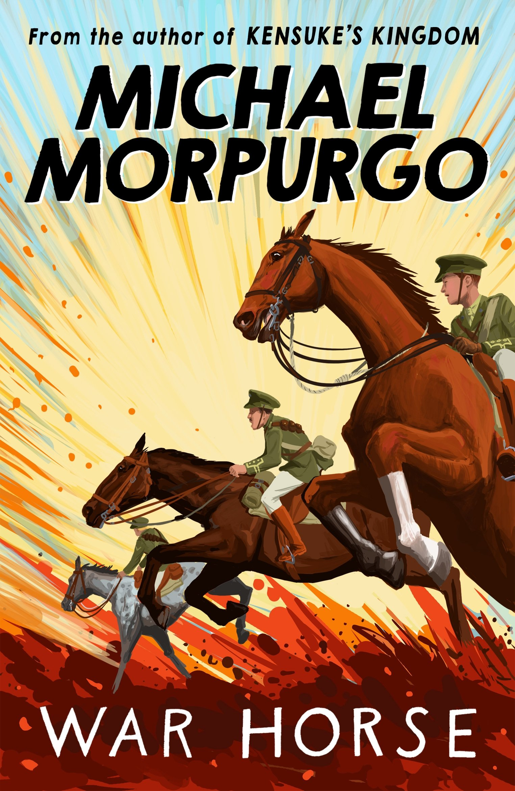
Using everyday materials to stay warm and safe in battle
Knowing the features of animals
Staying fit and healthy during wartime
Does Michael Morpurgo Use Science in His Stories?

