Year 3 Knowledge Mat  How much did Ancient Egypt change over time?  Change and continuity  Substantive concepts  Archaeologist, hieroglyphic, law, Ruler, civilisation, kingdom, crown, pharaoh, taxation, unity, enemies, god, goddess, religion, | 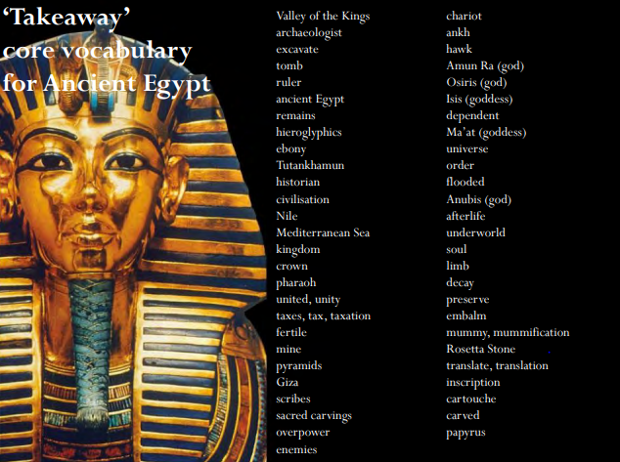  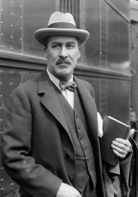  Howard Carter  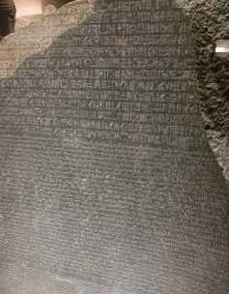  The Rosetta Stone
  What I should already know from Year 1
  How society/culture changed for our parents and grandparents. | How technology changed for our parents and grandparents.
  Sticky knowledge
  Location, origin in settlements around the Nile, living by the Nile, the role of the Nile in developing belief systems as well as agriculture. | How the power structures (pharaohs, the double crown) were linked to the geography of Egypt; how they were sustained through art, writing, belief systems.
  Ancient Egyptian religion, government, art, great monuments, beliefs about death, farming. | How Egypt changed through time - kingdoms, art, pyramids, beliefs and writing
Medium term plan
- Howard Carter gets a big surprise
- How did the ancient Egyptians live?
- How did ancient Egypt change over time?
- What did the ancient Egyptians believe?
- What did ancient Egyptians believe about death?
- How did the ancient Egyptians write?
Synoptic task

In what ways did ancient Egypt change?

National curriculum link

The achievements of the earliest civilizations – an overview of where and when the first civilizations appeared and a depth study of one of the following: Ancient Sumer; The Indus Valley; Ancient Egypt; The Shang Dynasty of Ancient China

