Year 3 Knowledge Mat  How similar and how different were Ancient Egypt and Ancient Sumer?  Similarity and difference  Substantive concepts  Farming, trade, city, religion, gods, king, civilisation, enemy, monuments, art, sculpture, religion, | 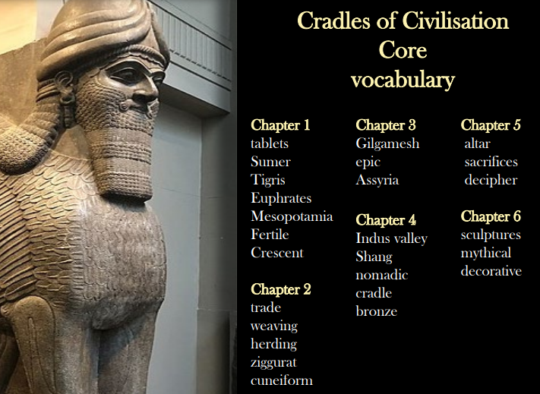  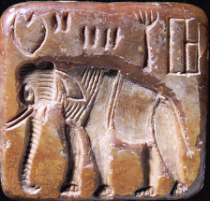  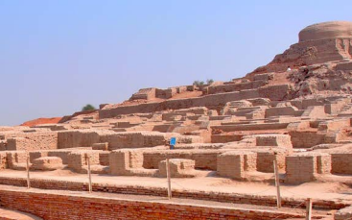  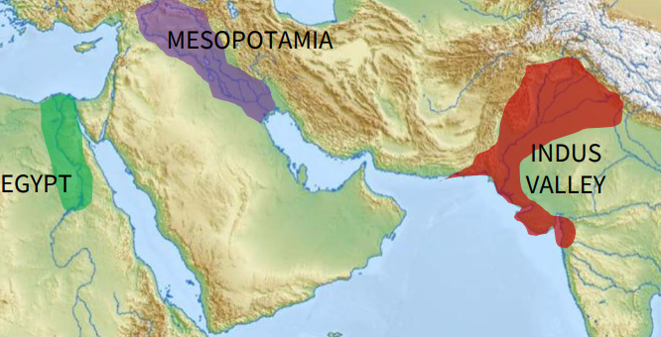
  What I should already know from KS1
  Similarities and differences between different historical periods. | Similarities and differences between significant individuals.
  Sticky knowledge
  The land between two rivers: Ancient Mesopotamia – the unique ‘cradle’ (development of writing to record trade). | Depth study of ancient Sumer in Mesopotamia via rivers & settlements (reinforce geog knowledge so far) and via art of ancient civilisations. Ziggurats
  Then, geographical overview of ancient civilisations of the world, inc. Big map seeing where they all were & geographical similarities.
Medium term plan

- The land of the two rivers
- Trade, building, writing The Epic of Gilgamesh
- Cradles of civilisation
- Similarities between civilisations
- Art in ancient civilisations
Synoptic task

In what ways were Egypt and Sumer the same and different?

National curriculum link

The achievements of the earliest civilizations – an overview of where and when the first civilizations appeared and a depth study of one of the following: Ancient Sumer; The Indus Valley; Ancient Egypt; The Shang Dynasty of Ancient China

