Progression in Language in Maths

Year 1 | Year 2 | Year 3 | Year 4 | Year 5 | Year 6
1NPV-1  Count forwards and backwards within 100.  “…seven, eight, nine, ten, eleven, twelve, thirteen… twenty, twenty-one, twenty-two…”  “…seven, eight, nine, one-ten, one-ten-one, one-ten-two, one-ten-three… two-tens, two-tens-one, two-tens two…” |  | 3NPV-1  Equivalence of 10 hundreds and 1 thousand.  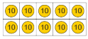  “10 tens is equal to 1 hundred.”  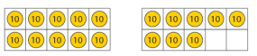  “18 tens is equal to 10 tens and 8 more tens.” “10 tens is equal to 100.” “So 18 tens is equal to 100 and 8 more tens, which is 180.”  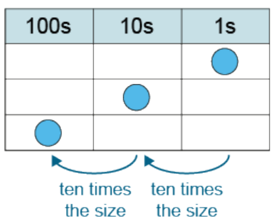  “100 is 10 times the size of 10.” | 4NPV-1  Equivalence of 10 hundreds and 1 thousand.  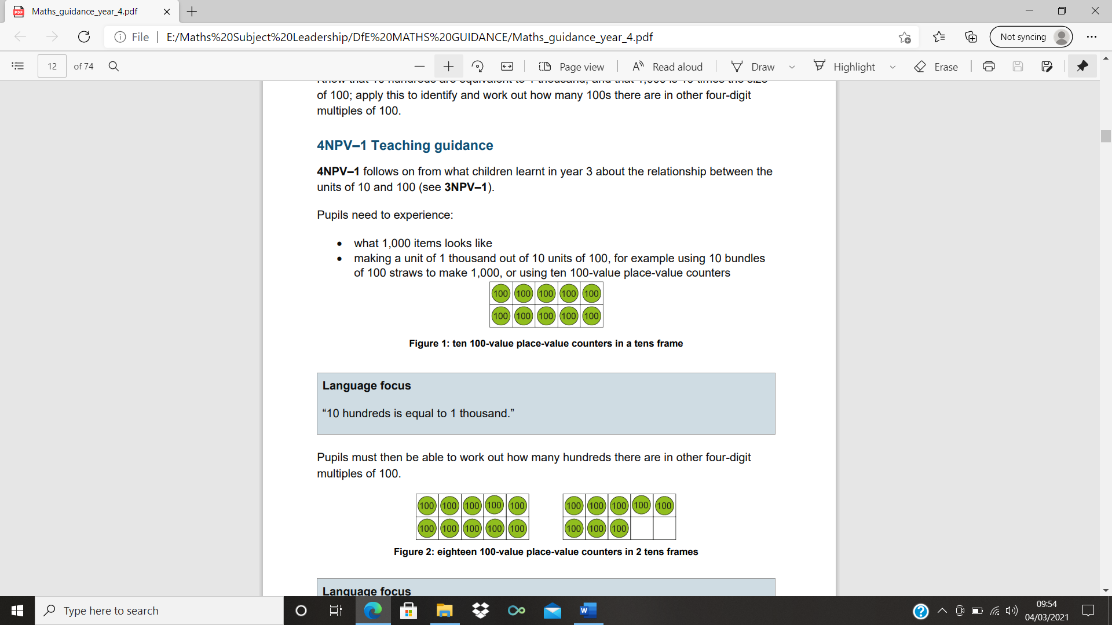  “10 hundreds is equal to 1 thousand.”  “18 hundreds is equal to 10 hundreds and 8 more hundreds.”  “10 hundreds is equal to 1,000.”  “So 18 hundreds is equal to 1,000 and 8 more hundreds, which is 1,800.”  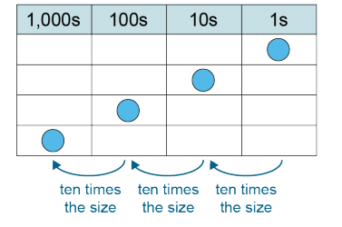  “1000 is 10 times the size of 100.”  “1,800 is 10 times the size of 180.” | 5NPV-1  Tenths and hundredths.  “1 is 10 times the size of one-tenth.”  “One-tenth is 10 times the size of one-hundredth.”  “1 is 100 times the size of one-hundredth.”  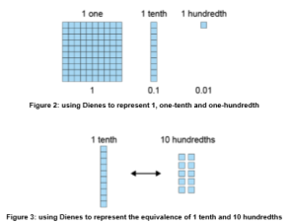  “10 tenths is equal to 1 one.”  “10 hundredths is equal to 1 tenth.”  “100 hundredths is equal to 1 one.”  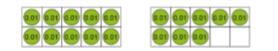  “18 hundredths is equal to 10 hundredths and 8 more hundredths.”  “10 hundredths is equal to 1 tenth.”  “So 18 hundredths is equal to 1 tenth and 8 more hundredths, which is 0.18.” | 6NPV-1  Powers of 10.  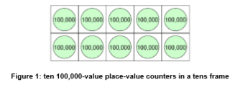  “10 hundred-thousands is equal to 1 million.”  “1,000,000 is 10 times the size of 100,000.” “100,000 is one-tenth times the size of 1,000,000.”  “10 thousands is equal to 10,000.”  “10,000 is 10 times the size of 1,000.” “1,000 is one-tenth times the size of 10,000.  “50,000 is 100 times the size of 500.” “500 multiplied by 100 is equal to 50,000.”  “500 is one-hundredth times the size of 50,000.” “50,000 divided by 100 is equal to 500.”
 | 2NPV-1  Place value in 2-digit numbers.  “This is the number 42. The 4 shows we have 4 groups of ten. The 2 shows we have 2 extra ones.” | 3NPV-2  Place value in 3-digit numbers.  “8 plus 6 is equal to 14, so 8 tens plus 6 tens is equal to 14 tens.” | 4NPV-2  Place value in 4-digit numbers. | 5NPV-2  Place value in decimal fractions.  “Three hundredths is zero-point-zero-three.” | 6NPV-2  Place value on numbers up to 10,000,000.  “In 67,000.4…  • the 6 represents 6 ten-thousands; the value of the 6 is 60,000  • the 7 represents 7 thousands; the value of the 7 is 7,000  • the 4 represents 4 tenths; the value of the 4 is 0.4”
1NPV-2  Numbers to 20 in the linear number system.  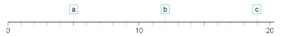 “a is 5 because it is halfway between 0 and 10.”  “b is 12 because it is 2 more than 10.”  “c is 19 because it is one less than 20.” | 2NPV-2  2-digit numbers in the linear number system.  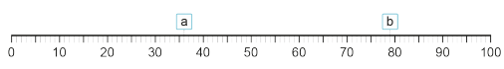  “a is 36 because it is one more than the midpoint of 35.”  “b is 79 because it is one less than 80.” | 3NPV-3  3-digit numbers in the linear number system.  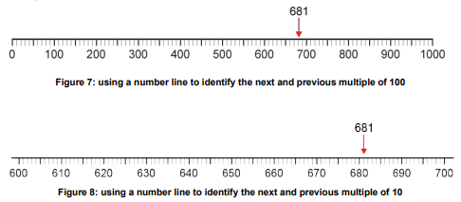  “The previous multiple of 100 is 600. The next multiple of 100 is 700.”  “The previous multiple of 10 is 680. The next multiple of 10 is 690.” | 4NPV-3  4-digit numbers in the linear number system.  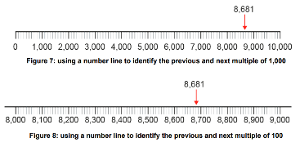  “The previous multiple of 1,000 is 8,000. The next multiple of 1,000 is 9,000.”  “The previous multiple of 100 is 8,600. The next multiple of 100 is 8,700.”  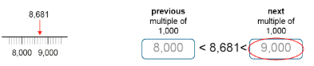  “The closest multiple of 1,000 is 9,000.”  “8,681 rounded to the nearest thousand is 9,000.” | 5NPV-3  Decimal fractions in the linear number system.  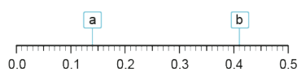  “a is 0.14 because it is 1 hundredth less than the midpoint of 0.1 and 0.2, which is 0.15.”  “b is 0.41 because it is 1 hundredth more than 0.4.” | 6NPV-3  Numbers up to 10 million in the linear number system.  “The previous multiple of 1 million is 5 million. The next multiple of 1 million is 6 million.”  “The previous multiple of 100,000 is 5,100,000. The next multiple of 100,000 is 5,200,000.”
 |  | 3NPV-4  Reading scales with 2, 4, 5 or 10 intervals.  “Twenty-five, fifty, seventy-five, one hundred” needs to be a fluent spoken language pattern, which pupils can continue over 100. | 4NPV-4  Reading scales with 2, 4, 5 and 10 intervals.  “Twenty-five, fifty, seventy-five, one hundred” needs to be a fluent spoken language pattern. Fluency in this language pattern provides the basis to count in multiples of 250. | 5NPV-4  Reading scales with 2, 4, 5 or 10 intervals.  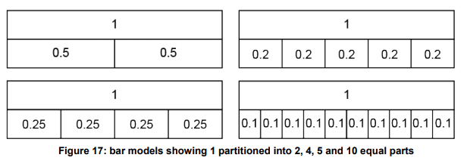  “Twenty-five, fifty, seventy-five, one hundred” needs to be a fluent spoken language pattern. Fluency in this language pattern provides the basis to count in multiples of 0.25. | 6NPV-4  Reading scales with 2, 4, 5 or 10 intervals.
5NPV-5
Converting between units of measure.

“1m is 100cm.” “So is 75cm.”

“1,000ml is 1 litre.” “So 3,000ml is 3 litres, and 3,700ml is 3.7 litres.”

“100p is £1.” “So 50p is £0.50, and 52p is £0.52.”
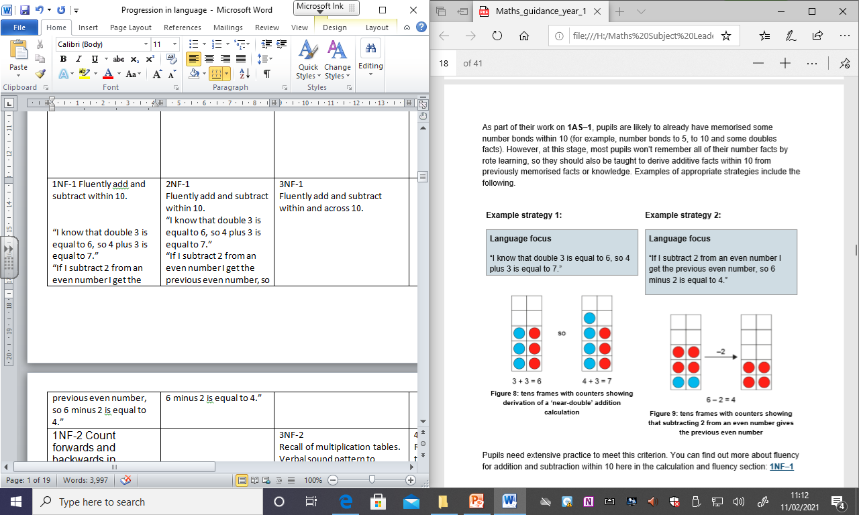  1NF-1 Fluently add and subtract within 10.  “I know that double 3 is equal to 6, so 4 plus 3 is equal to 7.”  “If I subtract 2 from an even number I get the previous even number, so 6 minus 2 is equal to 4.” | 2NF-1  Fluently add and subtract within 10. | 3NF-1  Fluently add and subtract within and across 10.
1NF-2 Count forwards and backwards in multiples of 2, 5 and 10.  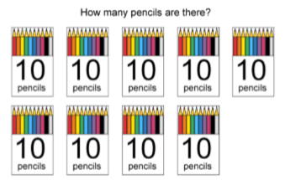  “The pencils are in groups of 10, so we will count in tens.”  “Ten, twenty, thirty…”  “1 group of 10, 2 groups of 10, 3 groups of 10…” In time, shortened to: “1 ten, 2 tens, 3 tens…” |  | 3NF-2  Recall of multiplication tables.  Verbal sound pattern to associate 3 relevant numbers.  “Six fours are twenty-four.”  “4 times 5 is 20, so 20 divided by 5 is 4.” | 4NF-1  Recall of multiplication tables.  Verbal sound pattern to associate relevant numbers.  “nine sevens are sixty-three”. | 5NF-1  Secure fluency in multiplication and division facts.
4NF-2
Division problems with remainders.

“If the dividend is a multiple of the divisor there is no remainder.”
“If the dividend is not a multiple of the divisor, there is a remainder.”
“The remainder is always less than the divisor.”

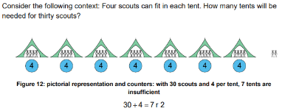

“The 30 represents the total number of scouts.”
“The 4 represents the number of scouts in each tent.”
“The 7 represents the number of full tents.”
“The 2 represents the number of scouts left over.”
“We need another tent for the 2 left-over scouts. 8 tents are needed.”

 |  | 3NF-3  Scaling number facts by 10.  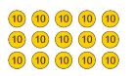  “3 times 5 is equal to 15.” “3 times 5 tens is equal to 15 tens.” “15 tens is equal to 150.”  “3 times 5 is equal to 15.” “3 tens times 5 is equal to 15 tens.” “15 tens is equal to 150.” | 4NF-3  Scaling number facts by 100.  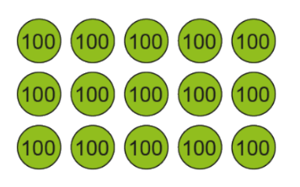  3 x 5 = 15  3 x 500 = 1500  “3 times 5 is equal to 15.”  “3 times 5 hundreds is equal to 15 hundreds.”  “15 hundreds is equal to 1,500.”  3 x 5 = 15  300 x 5 = 1500  “3 times 5 is equal to 15.”  “3 hundreds times 5 is equal to 15 hundreds.”  “15 hundreds is equal to 1,500.”  “If I multiply one factor by 100, I must multiply the product by 100.”  15÷3 = 5 1,500÷300 = 5 1,500÷3=500  “If I multiply the dividend by 100 and the divisor by 100, the quotient remains the same.”  “If I multiply the dividend by 100 and keep the divisor the same, I must multiply the quotient by 100.” | 5NF-2  Scaling number facts by 0.1 or 0.01.  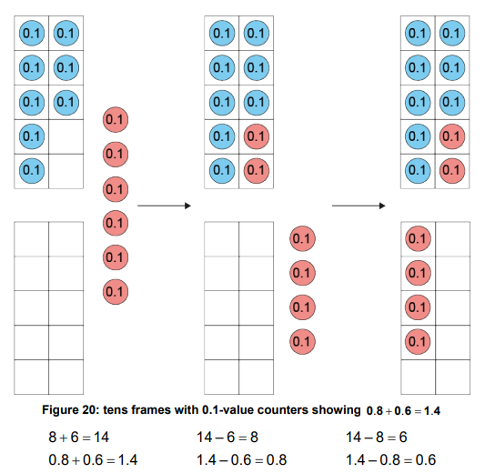  “8 plus 6 is equal to 14, so 8 tenths plus 6 tenths is equal to 14 tenths.”  “14 tenths is equal to 1 one and 4 tenths.”  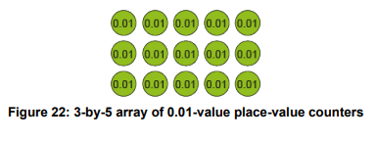  3 x 5 = 15  3 x 0.05 = 0.15  “3 times 5 is equal to 15.” “3 times 5 hundredths is equal to 15 hundredths.” “15 hundredths is equal to 0.15.”  3 x 5 = 15  0.03 x 5 = 0.15  “3 times 5 is equal to 15.” “3 hundredths times 5 is equal to 15 hundredths.” “15 hundredths is equal to 0.15.”  “If I make one factor one-hundredth times the size, I must make the product one-hundredth times the size.”  15 ÷ 3 = 15  0.15 ÷ 0.03 = 5  0.15 ÷ 3 = 0.05  “If I make the dividend one-hundredth times the size and the divisor one-hundredth times the size, the quotient remains the same.”  “If I make the dividend one-hundredth times the size and keep the divisor the same, I must make the quotient one-hundredth times the size.”
1AS-1  Compose and partition numbers to 10.  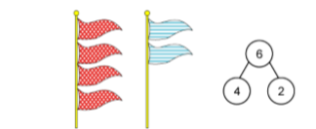  “There are 6 flags. 4 are spotty and 2 are stripy.”  “6 is the whole. 4 is a part. 2 is a part.” | 2AS-1  Add and subtract across 10. | 3AS-1  Calculate complements to 100.  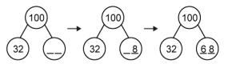  “First we make 10 ones. The ones digits add up to 1 ten, so we need 9 more tens.” |  |  | 6AS/MD-1  Quantify additive and multiplicative relationships.  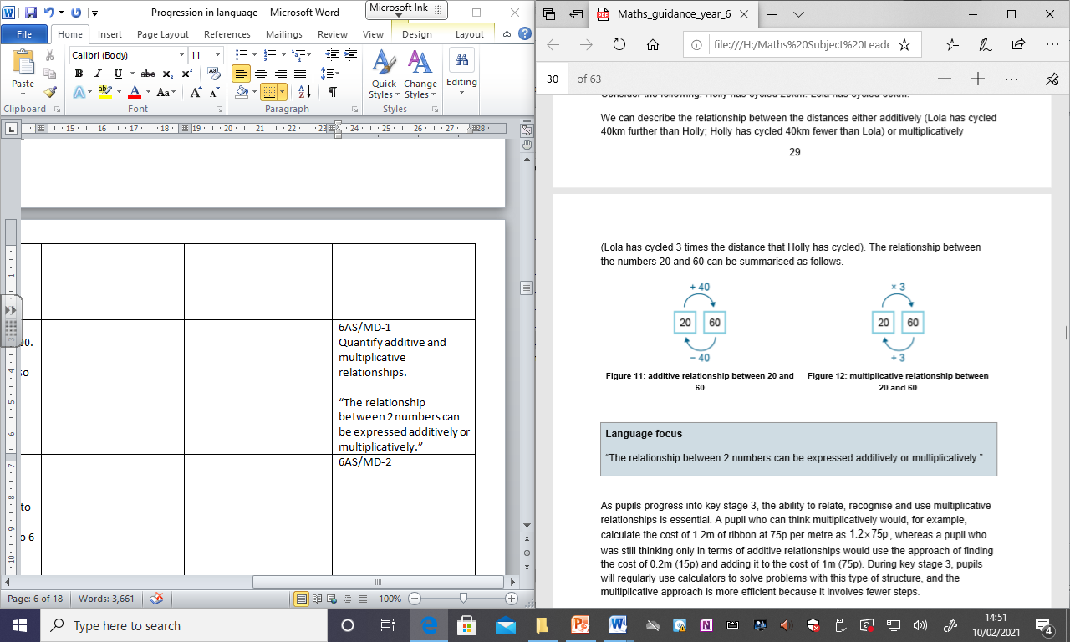  “The relationship between 2 numbers can be expressed additively or multiplicatively.”
1AS-2  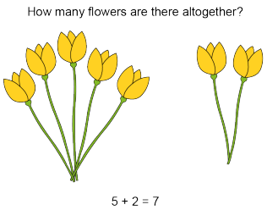  Read, write and interpret additive equations.  “There are 5 flowers in one bunch. There are 2 flowers in the other bunch. There are 7 flowers altogether.”  “We can write this as 5 plus 2 is equal to 7.”  “The 5 represents the number of flowers in 1 bunch.“  “The 2 represents the number of flowers in the other bunch.”  “The 7 represents the total number of flowers.”  ADDITION AS AGGREGATION  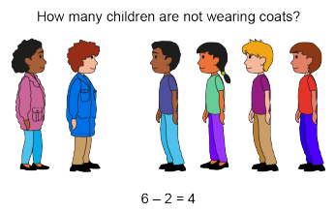  “There are 6 children altogether. 2 children are wearing coats. 4 children are not wearing coats.”  “We can write this as 6 minus 2 is equal to 4.”  “The 6 represents the total number of children.”  “The 2 represents the number of children that are wearing coats.”  “The 4 represents the number of children that are not wearing coats.”  SUBTRACTION AS PARTITIONING  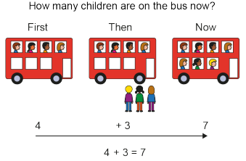  “First 4 children were sitting on the bus. Then 3 more children got on the bus. Now 7 children are sitting on the bus.”  “We can write this as 4 plus 3 is equal to 7.”  “The 4 represents the number of children that were on the bus at the start.”  “The 3 represents the number of children that got on the bus.”  “The 7 represents the number of children that are on the bus now.”  ADDITION AS AUGMENTATION  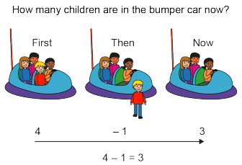  “First there were 4 children in the bumper car. Then 1 child got out. Now there are 3 children in the bumper car.”  “We can write this as 4 minus 1 is equal to 3.”  “The 4 represents the number of children that were in the car at the start.”  “The 1 represents the number of children that got out of the car.”  “The 3 represents the number of children that are in the car now.”  SUBTRACTION AS REDUCTION. | 2AS-2  Solve comparative addition and difference problems. | 3AS-2  Columnar addition and subtraction.  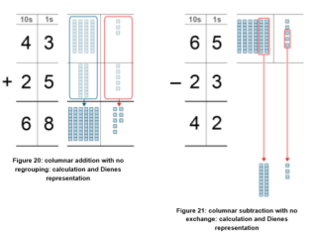  “3 ones plus 5 ones is equal to 8 ones.”  “4 tens plus 2 tens is equal to 6 tens.”  “5 ones minus 3 ones is equal to 2 ones.”  “6 tens minus 2 tens is equal to 4 tens.” |  |  | 6AS/MD-2  Derive related calculations.  70 + 2 = 72 60 + 12 = 72  “If one addend is increased and the other is decreased by the same amount, the sum stays the same.”  5 x 8 = 10 x 4  “If I multiply one factor by a number, I must divide the other factor by the same number for the product to stay the same.”  0.3 x 320 = 3 x ?  “If I multiply one factor by a number, and keep the other factor the same, I must multiply the product by the same number.”
 | 2AS-3  Add and subtract within 100.  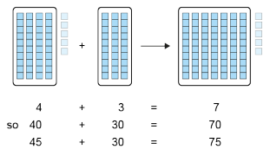  “4 plus 3 is equal to 7. So 4 tens and plus 3 tens is equal to 7 tens.”  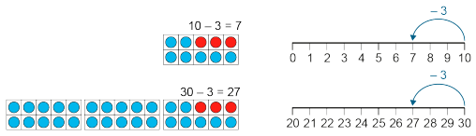  “10 minus 3 is equal to 7. So 30 minus 3 is equal to 27.”  “I know that 2 plus 5 is equal to 7, so 20 plus 50 is equal to 70. There are 9 ones as well, so 20 plus 50 is equal to 79.” | 3AS-3  Manipulate the additive relationship.  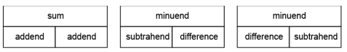  “If we swap the values of the subtrahend and difference, the minuend remains the same.”  • missing-addend problems (addend + ? = sum)  “There is a missing part. To find the missing part, we subtract the other part from the whole.”  329 + ? = 743 743 - 329 =?  • missing-subtrahend problems (minuend - ? = difference)  “There is a missing part. To find the missing part, we subtract the other part from the whole.”  477 - ? = 285 477 – 285 = ?  • missing-minuend problems (? - subtrahend =m difference)  “There is a missing whole. To find the missing whole, we add the 2 parts.”  ? – 527 = 87 527 + 87 = ? |  |  | 6AS/MD -3  Solve problems involving ratio relationships.  “For every 1 cup of rice you cook, you need 2 cups of water.”  “For every 10 children on the school trip, there must be 1 adult.”  “For every 2 yellow beads there are 3 green beads”.
 | 2AS-4  Add and subtract within 100.  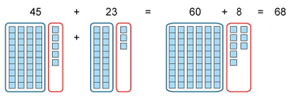  “First I partition both numbers. Then I add the ones. Then I combine all of the tens and all of the ones.” |  |  |  | 6AS/MD-4  Solve problems with 2 unknowns.
 | 2MD-1  Multiplication as repeated addition.  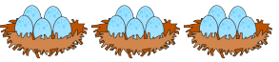  “There are 3 equal groups of eggs.”  “There are 5 eggs in each group.”  “There are 3 groups of 5.”  “The 3 represents the number of groups.”  “The 5 represents the number of eggs in each group.”  “The 15 represents the total number of eggs.” | 3MD-1  Multiplication and division structures.  “Factor times factor is equal to product.”  “The order of the factors does not affect the product.”  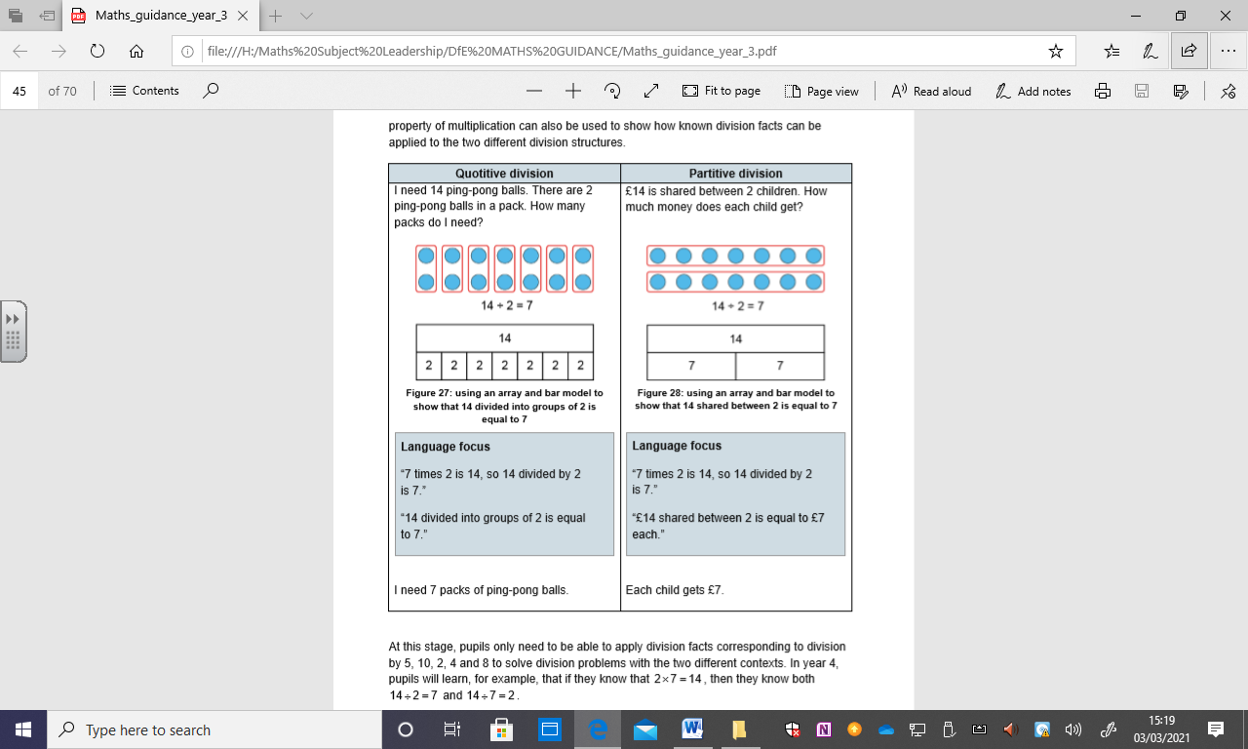  “7 times 2 is 14, so 14 divided by 2 is 7.”  “14 divided into groups of 2 is equal to 7.”  I need 7 packs of ping-pong balls.  “7 times 2 is 14, so 14 divided by 2 is 7.”  “£14 shared between 2 is equal to £7 each.”  Each child gets £7. | 4MD-1  Multiplying and dividing by 10 and 100.  “23, made 100 times the size, is 2,300.”  “23 multiplied by 100 is equal to 2,300.”  “First we had 23 ones. Now we have 23 hundreds.”  “1,450 is 10 times the size of 145.”  “1,450 divided by 10 is equal to 145.”  “First we had 145 tens. Now we have 145 ones.” | 5MD-1  Multiplying and dividing by 10 and 100.  “8, made one-tenth of the size, is 0.8.”  “8 divided by 10 is equal to 0.8.”  “First we had 8 ones. Now we have 8 tenths.”  “0.8, made 10 times the size, is 8.”  “0.8 multiplied by 10 is equal to 8.”  “First we had 8 tenths. Now we have 8 ones.”  “8cm is 10 times the length of 0.8cm.”  “0.25kg is one-hundredth times the mass of 25kg.”  “150 pencils is 10 times as many as 15 pencils.”
 | 2MD-2  Grouping problems: missing factors and division.  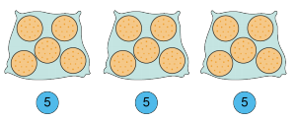  “The 15 represents the total number of biscuits.”  “The 5 represents the number of biscuits in each bag.”  “The 3 represents the number of bags.”  “15 divided into groups of 5 is equal to 3.” |  | 4MD-2  Manipulating the multiplicative relationship.  “2 groups of 3 is equal to 6.”  “3, two times is equal to 6.”  “2 groups of 3 is equal to 3, two times.”  “2 groups of 7 is equal to 14.”  “7 groups of 2 is equal to 14.”  “2 groups of 7 is equal to 7 groups of 2.”  “factor times factor is equal to product”  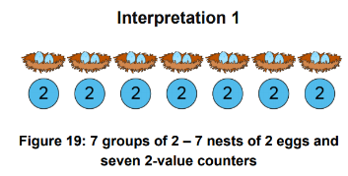  “The order of the factors does not alter the product.”  7 x 2 = 14  The 2 represents the number of eggs in each nest/group.  The 7 represents the number of nests/groups.  The 14 represents the number of eggs/product.  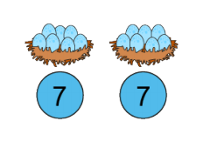  2 x 7 = 14  The 2 represents the number of nests/groups.  The 7 represents the number of eggs in each next/group.  The 14 represents the total number of eggs/product.  “If we swap the values of the divisor and quotient, the dividend remains the same.”  14 ÷ 7 = 2  14 shared between 7 is equal to 2.  The 14 represents the total number of eggs.  The 7 represents the number of nests/shares.  The 2 represents the number of eggs in each nest/share.  14 divided into groups of 7 is equal to 2.  The 14 represents the total number of eggs.  The 7 represents the number of eggs in each nest/group.  The 2 represents the number of nests/groups. | 5MD-2  Find factors and multiples.  “A multiple of a given number is the product of the given number and any whole number.”  “A factor of a given number is a whole number that the given number can be divided by without giving a remainder.”  “21 is a multiple of 3. 3 is a factor of 21.”  7 x 3 = 21  7 x 300 = 2100  700 x 3 = 2100  “21 is a multiple of 3, so… • 2,100 is a multiple of 300”  • 2,100 is a multiple of 3”
 |  |  | 4MD-3  The distributive property of multiplication.  5 x 6 = 3 x 6 + 2 x 6  3 x 6 = 5 x 6 – 2 x 6  2 x 6 = 5 x 6 – 3 x 6  “5 is equal to 3 plus 2, so 5 times 6 is equal to 3 times 6 plus 2 times 6.” | 5MD-3  Multiplying using a formal written method.  34 x 2 =  “2 times 4 ones is equal to 8 ones: write 8 in the ones column.”  “2 times 3 tens = 6 tens: write 6 in the tens column.”
5MD-4
Divide using a formal written method.

84 ÷ 4 =
“8 tens divided by 4 is equal to 2 tens: write 2 in the tens column.”
“4 ones divided by 4 is equal to 1 one: write 1 in the ones column.

 |  | 3F-1  Use and understand fraction notation.  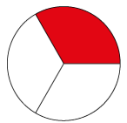  “The whole is divided into 3 equal parts. 1 of these parts is shaded.”  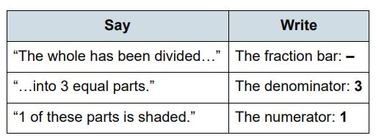  “The whole is divided into 3 equal parts. Each part is one-third of the whole.”  “The whole is divided into 8 equal parts and 5 of those parts are shaded. $\frac{5}{8}$ of the shape is shaded. .$\frac{5}{8}$ is 5 one-eighths.” |  |  | 6F-1  Simplify fractions.  “A fraction can be simplified when the numerator and denominator have a common factor other than 1.  “To convert a fraction to its simplest form, divide both the numerator and the denominator by their highest common factor.”
 |  | 3F-2  Find unit fractions of quantities.  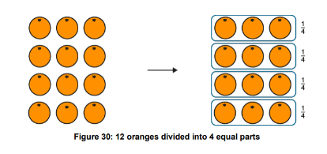  “The whole is 12 oranges. The whole is divided into 4 equal parts.” “Each part is $\frac{1}{4}$ of the whole. $\frac{1}{4}$ of 12 oranges is 3 oranges.”  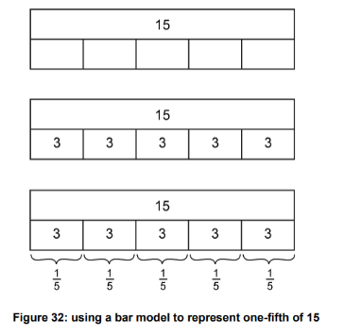  “To find $\frac{1}{5}$ of 15, we divide 15 into 5 equal parts.” “15 divided by 5 is equal to 3, so $\frac{1}{5}$ of 15 is equal to 3.” |  | 5F-1  Find non-unit fractions of quantities.  “To find $\frac{1}{5}$ of 15, we divide 15 into 5 equal parts.”  “15 divided by 5 is equal to 3, so $\frac{1}{5}$ of 15 is equal to 3.”  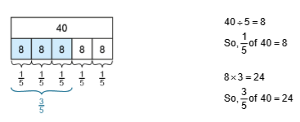  $\frac{3}{5}$ of 40 =  “Three-fifths is equal to 3 one-fifths.”  “To find 3 one-fifths of 40, first find one-fifth of 40 by dividing by 5, and then multiply by 3.” | 6F-2  Express fractions in a common denomination.  “We need to compare the denominators of $\frac{1}{5}$ and $\frac{4}{15}$.”  "15 is a multiple of 5.”  “We can use 15 as the common denominator.” “We need to express both fractions in fifteenths.”  “We need to compare the denominators of $\frac{1}{3}$and $\frac{3}{8}$.”  “8 is not a multiple of 3.”  “24 is a multiple of both 3 and 8.”  “We can use 24 as the common denominator.” “We need to express both fractions in twenty-fourths.”  “If one denominator is not a multiple of the other, we can multiply the two denominators to find a common denominator.”  “If the denominators are the same, then the larger the numerator, the larger the fraction.”
 |  | 3F-3  Fractions within 1 in the linear number system.  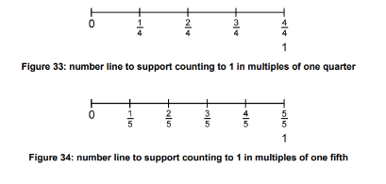  Pupils must practise dual counting:  “One fifth, two fifths, three fifths…”  “1 one-fifth, 2 one-fifths, 3 one-fifths…”  “… three-fifths, four-fifths, five-fifths”  “… three-fifths, four-fifths, one”.  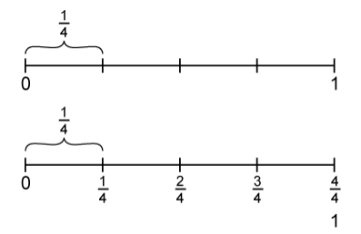  “Each whole-number interval is divided into 4 equal parts, so we count in quarters.” | 4F-1  Mixed numbers in the linear number system.  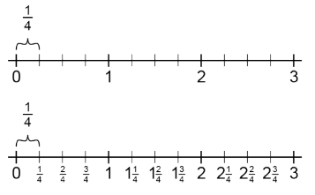  “Each interval is divided into 4 equal parts, so we count in quarters.”  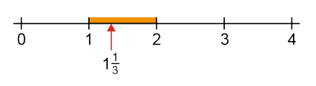  1$\frac{1}{3}$ is between 1 and 2.”  “The previous whole number is 1.”  “The next whole number is 2.” |  | 6F-3  Compare fractions with different denominators.  “If the numerators are both 1, then the larger the denominator, the smaller the fraction.  “If the numerators are the same, then the larger the denominator, the smaller the fraction.”
 |  |  | 4F2 – Convert between mixed numbers and improper fractions.  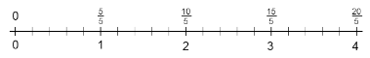  “When the numerator is a multiple of the denominator, the fraction is equivalent to a whole number.”  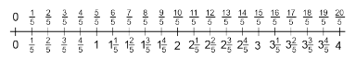  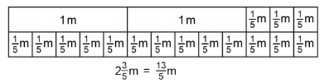  “There are 2 groups of five-fifths, which is 10 fifths and 3 more fifths. This is 13 fifths.”  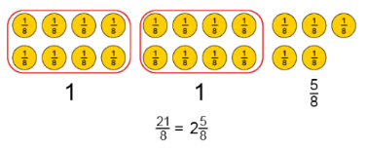  “We have 21 eighths. 8 eighths is equal to 1 (whole).”  “21 eighths is equal to 2 groups of 8 eighths, and 5 more eighths. This is 2 and 5 eighths.” | 5F-2  Find equivalent fractions.  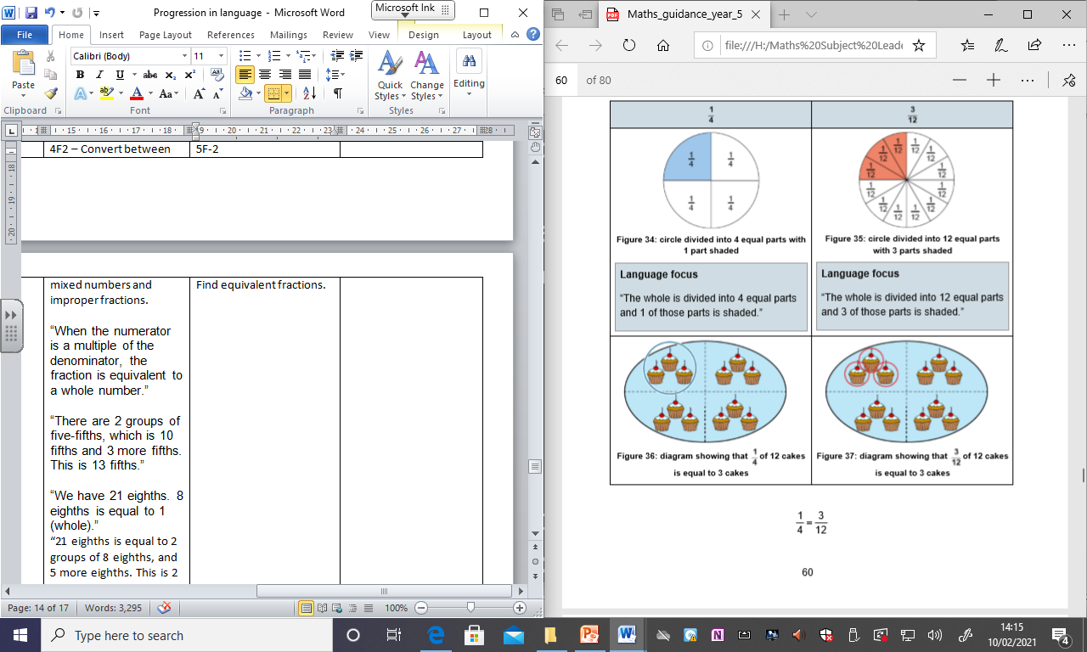  “The whole is divided into 4 equal parts and 1 of those parts is shaded.”  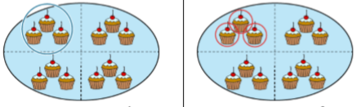  “The whole is divided into 12 equal parts and 3 of those parts is shaded.”  “$\frac{1}{4}$and $\frac{3}{12}$are equivalent because 1 is the same portion of 4 as 3 is of 12.”
 |  | 3F-4  Add and subtract fractions within 1.  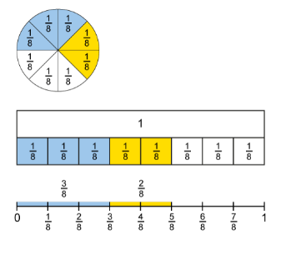  “3 one-eighths plus 2 one-eighths is equal to 5 one-eighths.”  “5 one-eighths minus 2 one-eighths is equal to 3 one-eighths.”  “When adding fractions with the same denominators, just add the numerators.”  “When subtracting fractions with the same denominators, just subtract the numerators.” | 4F-3  Add and subtract improper and mixed fractions (same denominator).  “7 one-fifths plus 4 one-fifths is equal to 11 one-fifths.”  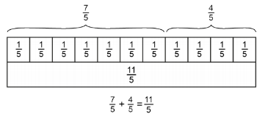  “When adding fractions with the same denominators, just add the numerators.”  “When subtracting fractions with the same denominators, just subtract the numerators.” | 5F-3  Recall decimal equivalents for common fractions.
1G-1 Recognise common 2D and 3D shapes.  Shape a: “This is not a triangle because it has 4 sides.”  Shape b or e: “This is a triangle because it has 3 straight sides.”  Shape c or d: “This is not a triangle because it has 6 sides.”  Shape f: “This is not a triangle because some sides are curved.” | 2G-1  Describe and compare 2D and 3D shapes.  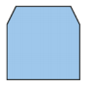  “This shape is a hexagon because it has exactly 6 straight sides.”  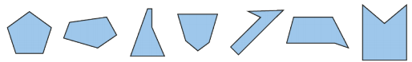  “These shapes are all pentagons because they all have exactly 5 straight sides.” | 3G-1  Recognise right angles. |  | 5G-1  Compare, estimate, measure and draw angles.  “An acute angle is smaller than a right angle.”  “An obtuse angle is larger than a right angle but less than the angle on a straight line.”  “A reflex angle is larger than the angle on a straight line, but less than the angle for a full turn.”  “D is the smallest angle. It is an acute angle.” “C is the largest angle. It is a reflex angle.”  “An acute angle is less than 90°.”  “An obtuse angle is greater than 90° but less than 180°.” “A reflex angle is greater than 180° but less than 360°.”
5G-2
Compare and calculate area.

“To find the area of a rectangle, multiply the length by the width.”

1G-2  Compose 2D and 3D shapes from smaller shapes. |  | 3G-2  Draw polygons and identify parallel and perpendicular sides.  “These 2 lines are parallel because they are always the same distance apart. They will never meet no matter how far we extend them.”  “These 2 lines are perpendicular because they are at right angles to each other.” | 4G-1  Draw polygons specified by coordinates or translation.  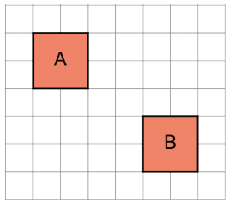  “The polygon has been translated 4 squares to the right and 3 squares down.”  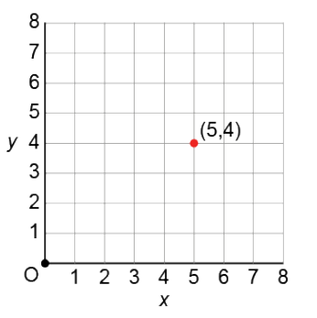  “First count along the x-axis, then count along the y-axis.” |  | 6G-1  Draw, compose and decompose shapes.
4G-2
Perimeter: regular and irregular polygons.

“This is a regular polygon, because all of the sides are the same length, and all of the interior angles are equal.”

4G-3
Identify line symmetry in 2D shapes.

“This is a line of symmetry because it splits the shape into two equal parts which are mirror images.”

