

Attendance and
Punctuality Policy

2025/26

1. INTRODUCTION

Full attendance maximises the opportunities for inclusion and achievement at school so that each pupil is able to realise their full potential.

All children between the ages of 5 and 16 are legally required to be educated.

Pupils, parents and carers, teachers, support staff and governors all have a role in maintaining a high standard of attendance and punctuality.

Aims of the Policy

- To develop a systematic approach to gathering, analysing and responding to attendance data.
- To implement a system of sanctions and rewards.
- To develop a framework which defines agreed roles and responsibilities for all people involved in maintaining pupil attendance and punctuality.
- To improve the overall attendance and punctuality of pupils at the school.

2. RECORDING ATTENDANCE DATA

Registers

The registers are completed electronically on Arbor by teaching staff at the beginning of the morning and afternoon sessions;

- KS1 at 8.50am and 1.00pm
- KS2 at 8.50am and 1.15pm

It is imperative that teachers ensure registers are completed twice daily and that either a present or absent mark is recorded against every pupil’s name, under no circumstances should registers be completed at a later time or date.

During morning registration pupils are able to access school via their own classroom doors from the moment the classroom doors are open until the following times:

- Classroom doors open at 8.50am, and pupils can enter via their classroom door until 9.05am.

If a parent or carer informs a member of staff at the classroom door of any reasons for a pupil’s absence this information should be recorded on Arbor in the comment box that can be applied to a child’s mark. Teachers should not allocate codes on Arbor for absences, this will be done by the Learning Mentors after further assessment and in line with the Head Teachers direction.

Recording of Reasons for Absence

Any reasons provided to the school office, teacher or teaching assistant in relation to a pupil’s absence must be recorded in a comment box that can be applied to that pupil’s mark on Arbor, and should be done at the earliest opportunity, but no later than 9.30am. Pupils with existing attendance concerns may be challenged by one of the Learning Mentors regardless of the reasons for absence already recorded.

Recording of Late Arrivals

Pupils who arrive at school late must enter via the main school office, where a member of the admin staff will record their name and arrival time on the inVentry sign-in system. The pupil will then receive a present mark next to their absence mark in the register to indicate they arrived at school late.

Pupils arriving at school after 9.30am are recorded as late after registration (LAR), a member of the admin staff will record their name and arrival time on the inVentry sign-in system. The pupil will then receive a present mark next to their absence mark in the register to indicate they have arrived at school late. At 9.30 inVentry is connected to the Learning Mentors computers and corrections are made to registers in real time in relation to appointments.

Compilation of Absence List

At 9.30am the Learning Mentor will transfer late arrival data from inVentry to Arbor, and will then begin reviewing marks in order to compile the daily absence list.

Medical Appointments

A pupil who has missed morning registration due to attending a medical appointment, but who then attends school immediately after will be given a M code, to encourage children to return to school straight after an appointment they will still receive an ice cream reward.

Lates

Any children who have two or more lates in a week will receive a punctuality letter ( see appendix) If parents receive two late letters in a half term the teacher will ask to speak to the parent to offer support and advice as to how to improve punctuality. If punctuality shows no improvement in the following three weeks parents will be invited to attend a meeting with the Head Teacher.

3. FIRST DAY RESPONSE TO ABSENCE

First Day Response Action

The Learning Mentor will review the absence list before proceeding in making telephone calls to the contact numbers of pupils with no reason for absence provided. Those pupils with ongoing attendance concerns will be contacted regardless of the reason for absence to challenge any reasons provided.

Where it is appropriate the Learning Mentor will conduct home visits to pupils who are absent from school, particularly in cases where language is considered to be a barrier, in cases of persistent absence, at risk of persistent absence or cases where there are safeguarding concerns.

All reasons obtained for a pupil’s absence will be recorded on the daily absence list, and a copy will be provided to the Head Teacher for review. The master daily absence list will be retained by the Learning Mentor for future reference and information providing to other staff and external agencies.

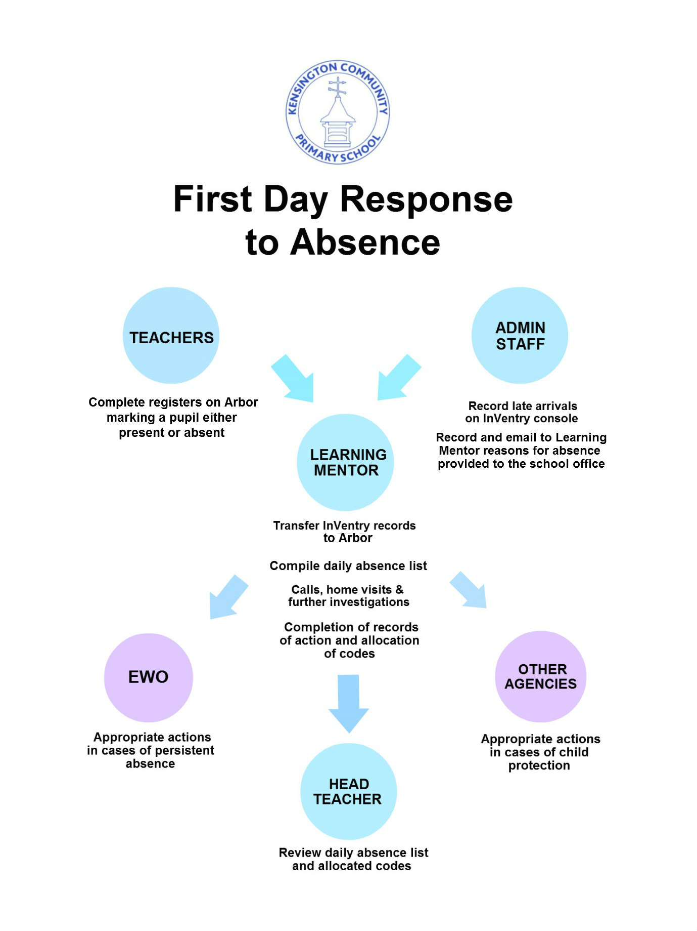

ABSENCE

An authorised absence is when a pupil is absent for a reason acceptable to the school. The school – not the parent – determines whether an absence is authorised after receipt of a verbal or written explanation from the parent/carer. Explanations from pupil’s or siblings are not sufficient.

Absences that will be authorised;

- Genuine illness
- Medical conditions
- Medical appointments (that cannot be taken out of school hours)
- Genuine family crisis or emergency
- Special leave that has been requested and then granted by the Head Teacher
- Religious holidays

Absences that will be unauthorised;

- Trivial illness (such as minor cough’s or cold’s)
- Reported illness when the child is later witnessed playing in the street
- Ongoing illness without proof (doctors note or copy of prescription)
- Ongoing medical conditions without proof (hospital appointment letter)
- Holidays
- Special leave that has not been requested and not authorised by the Head Teacher • Birthdays
- Tiredness
- Waiting in for repair men or deliveries
- Getting up late
- Not realising school was open
- Bad weather

Special Leave of Absence in Term Time

Parents are strongly discouraged from taking their children on holidays during term time.

In all cases of holidays or temporary return to home country the parent/carers are required to complete a Special Leave request form, if this form is not submitted the period of absence will automatically be unauthorised and school may proceed with registering the pupil as ‘Missing from Education’ (CME), which may also ultimately result in their removal from roll and their place being provided to another child.

Each application for special leave will be considered individually based on the nature of the event, history of term time holidays, the pupil’s current attendance, age, achievement, and the time of year with respect to the curriculum. Parents will be informed in writing of the decision on their request.

If a pupil does not return on the agreed date, the school will proceed in registering them as
‘Missing from Education’ (CME) and they will ultimately be removed from roll and their place may be provided to another child.

PERSISTENT ABSENCE

Persistent absence will be monitored on a daily basis by the Learning Mentor, and discussed on a weekly basis with the Education Welfare Officer (EWO).

The Learning Mentor will maintain tracking of pupils in or at risk of persistent absence, to ensure school-based interventions or the appropriate referrals to other agencies are made.

Once a pupil enters persistent absence status, the Learning Mentor will intervene and may meet with the parents/carers to discuss concerns, provide support or initiate appropriate referrals.

The threshold for persistent absence has been set at 10% meaning that any pupil with an attendance under 90% will be classed as a persistent absentee. An indication of half-termly breakdown of persistent absence criteria is detailed in the table below;

Half Term 1 | 7 or more sessions missed
Half Term 1-2 (Autumn Term) | 14 or more sessions missed
Half Term 1-3 | 20 or more sessions missed
Half Term 1-4 (Autumn and Spring Term) | 25 or more sessions missed
Half Term 1-5 | 31 or more sessions missed
Half Term 1-6 (Full academic year) | 38 or more sessions missed

Referral to Education Welfare

If, despite school’s intervention there is no sustained improvement in a pupils attendance a referral will be made to Education Welfare.

The Learning Mentor will discuss referrals with the local authorities Education Welfare Officer (EWO) on a weekly basis, and agree on an appropriate course of action.

Notice to improve:

- Learning mentors will track students’ attendance over 10 week rolling periods. Any student who has 10 unauthorised sessions of absence during any 10-week rolling period will be issued with a Notice to Improve.
- A Notice to improve is a 20-day window of consecutive school days where your child must have 100% attendance.
- Any absence during this time must be accompanied by Medical, or other appropriate, evidence.
- Failure to provide evidence for absences during the 20-day window will result in a Fixed penalty notice of £120 per parent (£60 if paid within 21 days)

Penalty Notices

- School will discuss with the EWO cases of persistent absence that may proceed with the issuing of a Penalty Notice where parents/carers have failed to bring about sustained improvement despite school’s intervention.

- Penalty notices will be issued in cases of unauthorised leave during term time that are 5 or more consecutive school days of absence.

Court Action

- In cases of continued persistent absence, especially those cases that involve pupils who have had persistent absence in previous academic years, the EWO may proceed with the process of taking court action against the parents/carers.

- All cases referred to Education Welfare will be considered individually, to ensure the most effective course of action and support to improve a pupil’s attendance is taken.

TAKING PUPILS OFF ROLL

- All pupils who leave Kensington Primary School to attend another school (except for secondary school transfers) will remain on roll until their admission elsewhere is confirmed. Once the pupils transfer has been confirmed the information must be submitted to the LCC school portal by a member of the admin staff.
- Parents/carers of pupil’s leaving Kensington Primary School must complete and return a ‘Pupil Leaving’ form, which are available from the main school office or on the school’s website. If a parent/carer fails to provide school with forwarding information then school and the local authority are required to carry out investigations to try and locate children, which includes liaising with Children’s Services, the Police and other agencies. If parents provide school with information requested on the ‘Pupil Leaving’ form, these investigations can be avoided.
- In the case of pupils who disappear (i.e. leave with no indication of where they are going or whether they will return), the Learning Mentors will make every effort to contact the family and proceed with the required 20 day process of registering a child as missing from education (CME). Only when this process has been completed will the pupil be removed from roll.

ADMISSION OF NEW PUPILS

- The parents/carers of new pupils admitted to Kensington Primary School will be provided with a copy of the schools ‘Guide to our Attendance Policy’.
- Details about any new pupil who has been admitted to Kensington Primary must be submitted to the LCC school portal.
- The parents/carers of any child admitted to Kensington Primary School with an existing history of attendance issues at their previous school, must attend a meeting with the Learning Mentor/Head Teacher prior to starting.
- The parents/carers of any child admitted to Kensington Primary School who are attending school but travelling a significant distance on foot (over 1 mile from school), will meet with the Head teacher or Learning mentors to discuss if there are schools which are closer to their home that they can attend more easily.

MONITORING ATTENDANCE AND RESPONDING TO PATTERNS OF ABSENCE

School staff will ensure they fulfil their responsibilities as described in the school’s attendance policy, to ensure an effective and co-ordinated response to attendance issues.

The Learning Mentor will produce a termly briefing that will;

- Provide key attendance data (such as overall attendance, punctuality and persistent absence rate).
- Charts providing a breakdown of pupils in different attendance levels.
- Weekly whole school attendance and punctuality tracking charts.
- Weekly individual class attendance and punctuality tracking charts.
- Information on pupils with persistent absence and the intervention taken.
- Information on pupils with persistent absence who were referred to the EWO and details of the action taken.
- Narrative of identified issues affecting attendance and punctuality, and recommendations for effective strategies and interventions to respond to them.

The briefing will be made available to the Head Teacher, Governors and EWO. A master copy will be retained by the Learning Mentor for information providing to other staff and external agencies.

SAFEGUARDING REVIEWS OF PUPILS WITH ATTENDANCE CONCERNS

The Learning Mentor will report on all pupils with attendance concerns during the school’s monthly Safeguarding Team meetings, which will be attended by the Head Teacher, Deputy Head and SENCO/ Designated Safeguarding Lead and both Learning Mentors.

ENCOURAGING GOOD ATTENDANCE AND PUNCTUALITY

Whole school activities will raise the profile of attendance and punctuality issues and encourage good attendance and punctuality.

Targeted interventions and individual support to both pupils and parents will help tackle specific issues affecting attendance or punctuality.

The message ‘In School, On Time, Every Day’ will continue to be promoted throughout school and the wider community as a declaration of Kensington Primary School’s high expectations in relation to attendance and punctuality.

The message will be promoted by;

- Simple RAG traffic light system evaluation of attendance levels to clearly identify 97% as the minimum attendance level school expects for pupils to attain.
- Attendance signage and information displayed in the reception entrance.
- Internal school displays.
- Message highly visible on attendance guides/leaflets.
- Message featured on all attendance and punctuality correspondence with parents/carers.
- A dedicated attendance page on the school website.
- Regular promotion of good attendance and punctuality on the school twitter account, with the repeated use of the #inschoolontimeeveryday, #magicmoments, magicmomentshappenhere and #to97andbeyond
- Posters with message displayed on every external classroom door, and in prominent positions around the school building.
- Daily announcement of classes achieving 100% attendance.
- Individual interventions with Learning Mentors.

REWARDING GOOD ATTENDANCE AND PUNCTUALITY

Good attendance and punctuality will be acknowledged on a daily, weekly, half-termly and annual basis with a range of rewards and incentives.

Pupils will be incentivised to achieve good attendance through two key whole school initiatives;

- A ‘Magic Moments Ice Cream’ awarded to every pupil who is in school, on time, every day for the full week.
- An invitation to a special event at the end of the school year for all pupil’s who achieve an attendance of ‘97% and beyond!’

COMMUNICATING WITH PARENTS

It is essential that the parents/carers of all pupils understand the school’s attendance policy and their responsibilities to ensure their child maintains good attendance and punctuality.

Information regarding the school’s attendance policy will be provided by;

- Every parent/carer receiving a copy of the schools ‘Guide to our Attendance Policy’ at the start of the new school year.
- The school’s attendance policy will be made available on the school website.
- Parents/carers of new pupils will be provided with a copy of the schools ‘Guide to our Attendance Policy’ when completing the enrolment process.
- Copies of a ‘Guide to our Attendance Policy’ will be made available at the school office.
- The school’s attendance policy will be re-enforced in all appropriate communication with parents and any intervention meetings.

School will keep parents/carers informed of their child’s attendance and punctuality throughout the year by;

- ‘Thank you’ letters for parents of children who have achieved 100% attendance at strategic points during the school year.
- Informing parents of children who are regularly late of the negative impact of poor punctuality, with weekly late letters.
- Providing termly notifications to parents/carers of their child’s attendance using the RAG evaluation levels.
- Providing parents/carers with a verbal notification of their child’s attendance during every phone call made by the Learning Mentors during ‘First Day Response’.
- Providing parents/carers with written notification of their child’s attendance during home visits made by the Learning Mentor or EWO.
- Teachers will make reference to a pupil’s attendance and punctuality during parent’s evenings, and the pupils attendance and punctuality record will also be provided in the pupils annual school report.

School will share the celebration of good attendance throughout the year by;

- Sharing the class attendance on the class page of the school’s website each week
- Sharing Magic Moments Ice Cream rewards on the school’s twitter page every week.
- Make reference to Magic Moments Ice Cream rewards in school newsletters or other suitable correspondence with parents/carers.
- Promoting the end of year reward for attendance of 97% and beyond.
- Inviting parents/carers of pupils with outstanding attendance to end of year celebrations.

APPENDICES

Attendance and Punctuality Roles and Responsibilities

Whom |  | Daily Actions Expected
Pupils | • | Arrive at school on time, at 8.50 am every day
Class  Teacher | •  •  • | Complete accurate register on Arbor every morning (by 9.30am)  Complete accurate register on Arbor every afternoon (by 1.30pm)  Report any information relating to an absence on Arbor or to the Learning Mentor as soon as possible
 | • | Ensure attendance has a high profile in class
 | • | Ensure welcoming environment to pupils who return after a period of absence
Admin Staff | • | Ensure any reasons for absence reported to school via phone, email, app or in person at the office are recorded on Arbor
 | • | Ensure that children arriving late are recorded appropriately on inVentry
 | • | Make First Day Response calls if required
 | • | Assist in providing parents with/obtaining information for ‘Pupils Leaving’ and ‘Requests for Leave of Absence’
 | •  • | Ensure any completed ‘Pupil Leaving’ forms are given to the Learning Mentor as soon as possible  Ensure any completed ‘Requests for Leave of Absence’ are given to the Head Teacher as soon as possible
Learning Mentors | •  •  • | Ensure Arbor marks for every class have been completed and appropriate codes applied  Ensure late arrival marks are transferred from inVentry to Arbor regularly throughout the day  Compile ‘Daily Absence List’ of all pupils who are absent, with reasons and codes allocated
 | • | Contact via phone, text, email or home visit parents/carers of pupils absent with existing attendance concerns
 | • | Make home visits to absent pupils who are persistent absentees or for whom there are safeguarding concerns
 | • | Provide pastoral support to pupils with ongoing attendance concerns
 | • | Liaise with other staff (admin, SENCO) to obtain and share information relating to a pupil’s absence
 | • | Liaise with external agencies (EWO, Children’s Services) as appropriate relating to a pupil’s absence
 | • | Record all reasons for absence obtained by first day response procedures and provide copy of completed ‘Daily Absence List’ with codes allocated to head teacher for review
 | • | Provide ‘Daily Class Attendance’ chart to Head Teacher
Head  Teacher | •  •  • | Report any information relating to an absence on Arbor or to the Learning Mentor as soon as possible.  To ensure that all statutory regulations in relation to attendance are followed.  Respond to parents request for leave of absence applications.
Whom |  | Weekly Actions Expected
Class  Teacher | • | Share any information with Learning Mentor that relates to issues that may contribute to a pupil’s absence (i.e. pupils going on a holiday, moving house, incident in school)
 | • | Support and promote attendance initiatives and rewards
Admin Staff | • | Send out weekly late letters to parents/carers of pupils who arrived late on 2 or more occasions during the previous week (Learning Mentors will notify admin staff if any late arrivals should not receive letters due to legitimate reasons)
Learning Mentors | • | Audit Arbor marks at the end of each week to ensure that all absences have been allocated an appropriate mark and that records are accurate
 | • | Update Persistent Absence Intervention and Tracking files
 | • | Provide targeted pastoral intervention to pupils with attendance concerns
 | • | Prepare referrals to EWO and complete necessary forms
 | • | Meet in person or by phone with the Education Welfare Officer (EWO) every week to discuss referrals and agree interventions
 | • | Meet with parents/carers of persistent absentees when required (including with EWO when necessary)
 | • | Home visit with EWO on cases that require support
 | • | Liaise with external agencies to obtain support for families on issues that may be contributing factors to attendance issues
 | • | Inform parents/carers of pupils with attendance issues of school’s concerns with appropriate letters
 | • | Identify and implement weekly rewards for attendance successes across the school
Head  Teacher | •  • | Inform pupils and staff of attendance figures for previous week in the Monday morning assembly and in staff briefing  Participate in the implementation of weekly rewards for attendance successes across the school
EWO | • | Meet in person or by phone consultation with the Learning Mentor every week to discuss referrals and agree interventions

Whom |  | Half-Termly Actions Expected
Learning Mentors | • | Attend safeguarding team meetings to report on attendance concerns, persistent absentees and interventions, share information and agree actions
 | • | Send out half-termly attendance record updates to parent/carers of pupils with persistent absence or absence predominantly for authorised/medical reasons
Admin Staff | • | Prepare half-termly attendance record updates for all pupils in the categories 97% - 100% and under 97%
 | • | Ensure all attendance record updates are enveloped before going out
Head Teacher  Deputy Head SENCO | • | Attend safeguarding team meetings to share information and discuss and agree interventions for pupils with attendance concerns

Whom |  | Termly / Annual Actions Expected
Class  Teacher | •  • | Provide accurate attendance and punctuality record on pupils end of year school report  Make reference to impact on education of pupils with attendance concerns as appropriate during parent’s evenings
Admin Staff | • | At the start of each new school year (September) prepare annual attendance record letters for previous school year for all pupils in the categories 97%-100% and under 97%
 | • | Ensure all attendance record updates are enveloped
Learning Mentors | •  •  • | At the start of each new school year (September) prepare annual attendance record letters for previous school year for all pupils with persistent absence or absence predominantly for authorised/medical reasons  At the start of each new school year provide all parents/carers with a copy of the schools ‘Guide to Our Attendance Policy’  At the start of each new school year meet with parents/carers of pupils identified as persistent absentees from the previous year to discuss support and further actions as appropriate
 | • | At the end of each school year check the attendance history of all year 6 pupils to identify any that have maintained 100% throughout their primary education
 | • | At the end of each school year identify all pupils with 100% for the school year and organise appropriate reward to be presented in final assembly of the year
EWO | • | At the start of each new school year agree Service Level Agreement with school
 | • | At the start of each new school year meet with parents/carers of pupils identified as persistent absentees from previous year to discuss support and further actions as appropriate

Attendance Levels and Interventions

Attendance % | RAG | Intervention | Lead Responsibility
100%  Attendance is excellent |  | Rewards and praise | Class Teacher  Learning Mentor  Head Teacher
97% - 99%  Attendance is good |  | Rewards and encouragement | Class Teacher  Learning Mentor  Head Teacher
Under 97%  Attendance is a concern |  | Priority contact in First Day Response, including home visits when appropriate  Engagement with parents/carers to provide early warning of concerns  Individual interventions and support to pupils identified as having attendance concerns  Penalty Notices | Class Teacher  Learning Mentor  EWO
Under 90%  Attendance is a serious concern |  | Critical contact in First Day Response, including priority home visits  Individual interventions and support to pupils with persistent absence  EWO casework, escalation of actions in  cases of no improvement  Penalty Notices  Court Action (Prosecution) | Learning Mentor  Safeguarding Team  EWO  Outside Agencies




Date: September 2025
Review Date: September 2026

